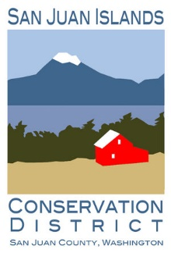

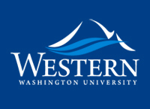

Application to the Ecological Restoration Certificate in the

San Juan Islands
Applications are due April 30th, 2023

Please either fill out as a word document and email to kai@sjicd.org or print and submit to the San Juan Islands Conservation District at 530 Guard Street, Friday Harbor 98250

Name:
Email:
Phone number:
Present address:
Age:
Ethnicity:
What is your highest level of education:

1.Tell us about your employment goals moving forward:

2. Please describe relevant work experience in the field of natural resources:

3. How would the work and education in the field of restoration ecology support your goals moving forward?

4. What do you do for fun?

5. Do you have a car or a method of transportation?

6. Describe your capacity to access housing in the San Juan Islands:

7. What issues of ecology are you most interested in?

8. Please provide contact information for two previous employers:

