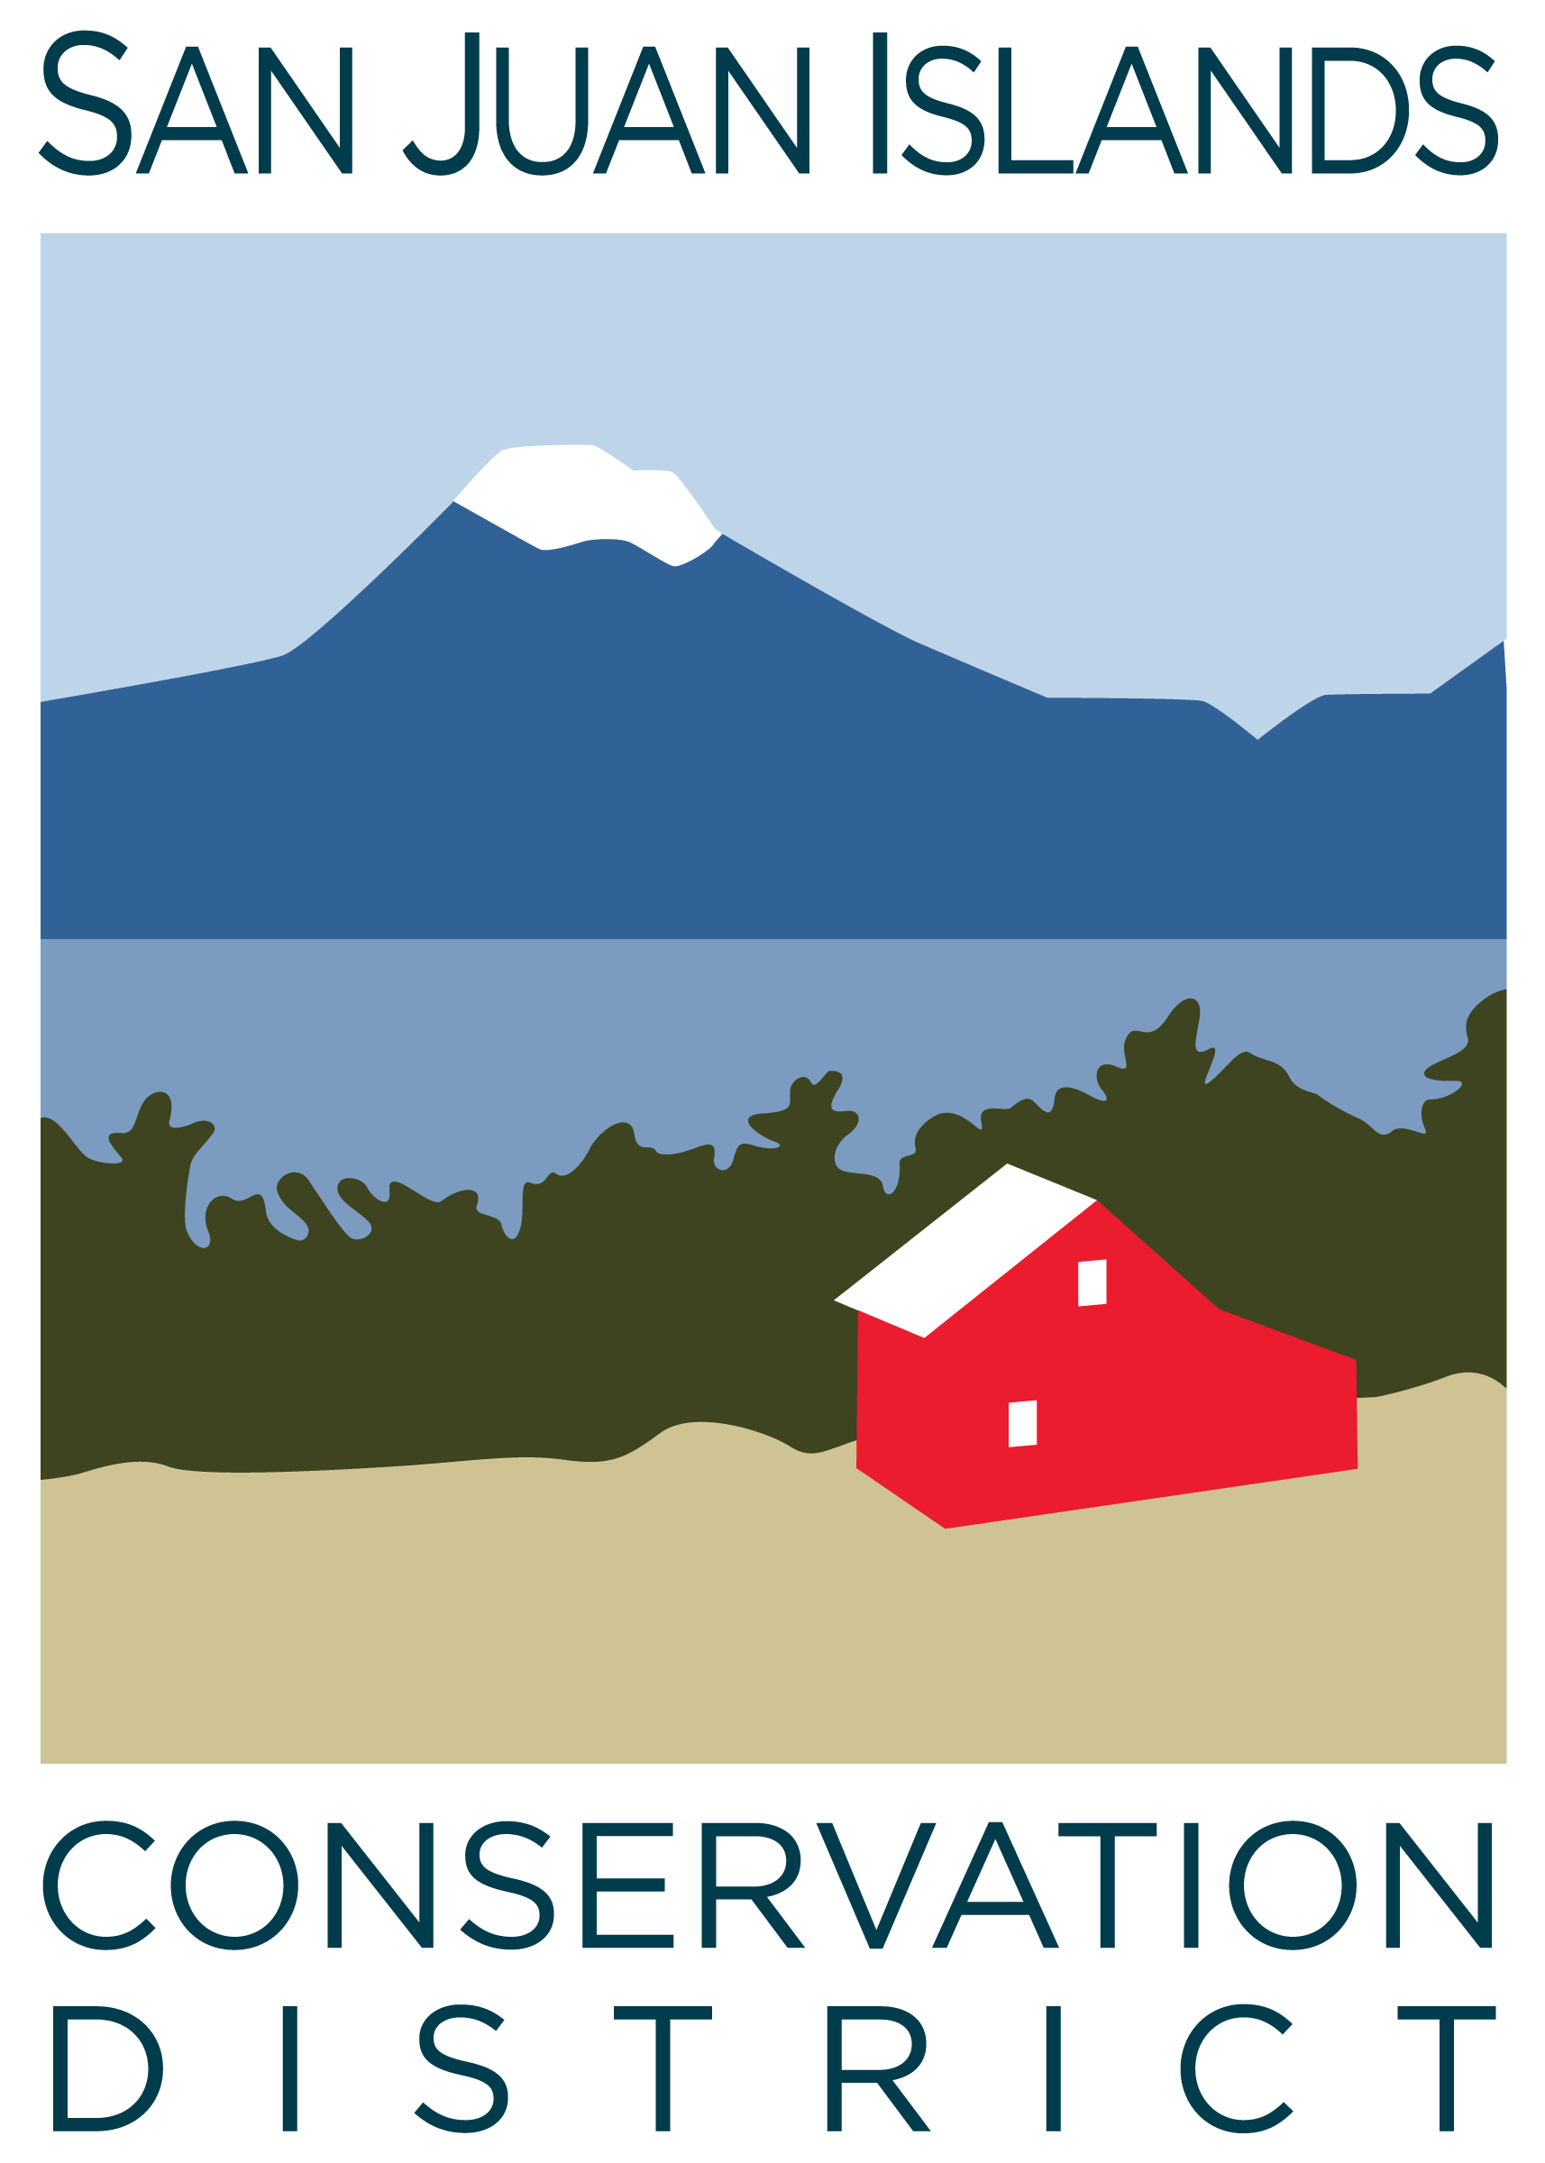
San Juan Islands Conservation District
BOARD OF SUPERVISORS
REGULAR MEETING MINUTES

Date: | December 19, 2025
Time: | 9:00am – 11:10am
Place: | 915 Spring St. Friday Harbor, WA 98250  And online via Zoom
Attending Supervisors: | David Bill, Lynn Bahrych, Vicki Heater, Claire Crawbuck
Partners: | Alan Chapman, WACD NW Region Representative; Robin Buckingham, NRCS
Staff: | Paul Andersson, Tony Fyrqvist
Public:

 | Welcome and Introductions
1 | Agenda Approval
 | The Agenda was approved by consensus.
2 | Minutes Approval: November 21, 2025 Regular Meeting, and December 8, 2025 Special Meeting
 | Action Item: Claire made a motion to approve the November-25 Regular Meeting Minutes. The motion was seconded by David and approved.
 | Action Item: David made a motion to approve the December-8 Special Meeting Minutes. The motion was seconded by Claire and approved.
3 | Public Comments
 | None.
4 | Partner Reports
Robin Buckingham, NRCS:
- 25% of statewide NRCS funding in 2026 is earmarked for the Regenerative Ag Pilot Program helping farmers adopt soil health practices like cover cropping and nutrient management – similar to Climate Smart Programs.
- 50% of available funding in 2026 will be allocated to emergency/disaster assistance related to the recent flooding.
- The Emergency Watershed Protection Fund has available assistance for properties impacted by shoreline erosion along with some buyout opportunities for affected properties.
- NRCS is catching up on work being 1.5 months behind due to recent government shutdown and the resulted losses in staff and funding.
- The Farm Bill has been extended through 2026 and the deadline for program application is 1/15/26.

Alan Chapman, WACD
- 25% of Supervisors participated in the voting on Resolutions at this year’s WACD annual conference.
- 50% of Supervisors participated in in the selection of the NW Area Representative. Bill Blake was elected.
- The 2026 WACD Annual Meeting & Conference in Dec-26 is scheduling the business meeting for Saturday so that working Supervisors have an improved chance to attend.
- Participation is encouraged in WACD survey on how to serve Districts more efficiently.
- A suggestion has been made to allow District Executive Directors to participate in the voting for Resolutions.
5 | Financial Report – Nov-25 Financials
 | Action Item: The Financial Manager reviewed the 11/30/25 Financial Summary as presented. Emphasis was placed on the fact that the District transferred additional funds to the Reserve Account now covering up to 3 months of payroll. David made a motion to approve the Credit Card Details and Payroll reports and was seconded by Claire. The motion passed.
6 | Old Business
Discussion: March 18-19 WSCC Commission Meeting on San Juan Island – Tour and Dinner Itinerary
- Tour itinerary suggestions include Overmarsh Commons ag project, Beaverton Marsh forestry project, Krystal Acres afforestation and riparian projects, Zylstra Lake riparian project, Island Marble Butterfly and Eelgrass restoration, and various Cost Share supported programs. Also a visit to Lime Kiln State Park Lighthouse being a notable destination for observing Southern Resident Killer Whales.
- Tour bus for 40-50 people.
- Dinner and lodging alternatives.
- Meeting location potentially at Brickworks or Grange.
- Possible boat tour on Friday after the Thursday meeting.
 | Action Item: David made a motion to approve the amended Resolution 2025-006, SJC Rates and Charges appeals process. Motion was seconded by Claire and the motion passed.
 | Discussion: The next step for organizational development includes finding a facilitator and scheduling a workshop between board and senior district staff members.
7 | New Business
 | Action Item: Claire made a motion seconded by Vicki to approve the 2026 board meeting dates of every 4th Friday from 9-11am with exceptions for November and December to accommodate the holidays. The motion was approved.
 | Discussion Item: The board retreat/work session date will be determined after finding a facilitator.
 | Action Item: Lynn made a motion seconded by Claire to approve the amended Reserve Fund Policy. The motion was approved.
8 | Staff and Program Reports
- Staff and Program Report was provided to the board.
- The board extended appreciation to Liz Scranton from Lopez for her support and contributions to YCC.
- Biochar kiln workshops are being scheduled.
9 | Recent & Upcoming Trainings/Webinars/Events
WACD Annual Conference on December 1-3 at the Northern Quest Resort and Casino in Spokane was attended by Lynn and Paul, issues covered included:
- The requirement of 3-5 Supervisors being landowners.
- Completion of the F-1 Financial Statement by Supervisors.
- Election rules.
- Code of Conduct, Public Records Act, Public Meetings Act, conflicts of interest and monetary penalties for violations.
10 | Idea Pot
Discussion items:
- Benefits and drawbacks of an Associate Supervisor.
- Use and environmental impact of Cost Share funding within long term goals
- Remove language in user agreement referencing “for-profit use” of the No Till Drill by farmers.
- District providing lunch, or having a regular pot luck lunch days, at the District Office to further improve staff cohesion while respecting the national debate between remote work and working from the office.
11 | Adjourn Regular Meeting 11:10 am
Next Meeting: | Regular Meeting - Friday, January 23, 2026, from 9:00am to 11:00am.

