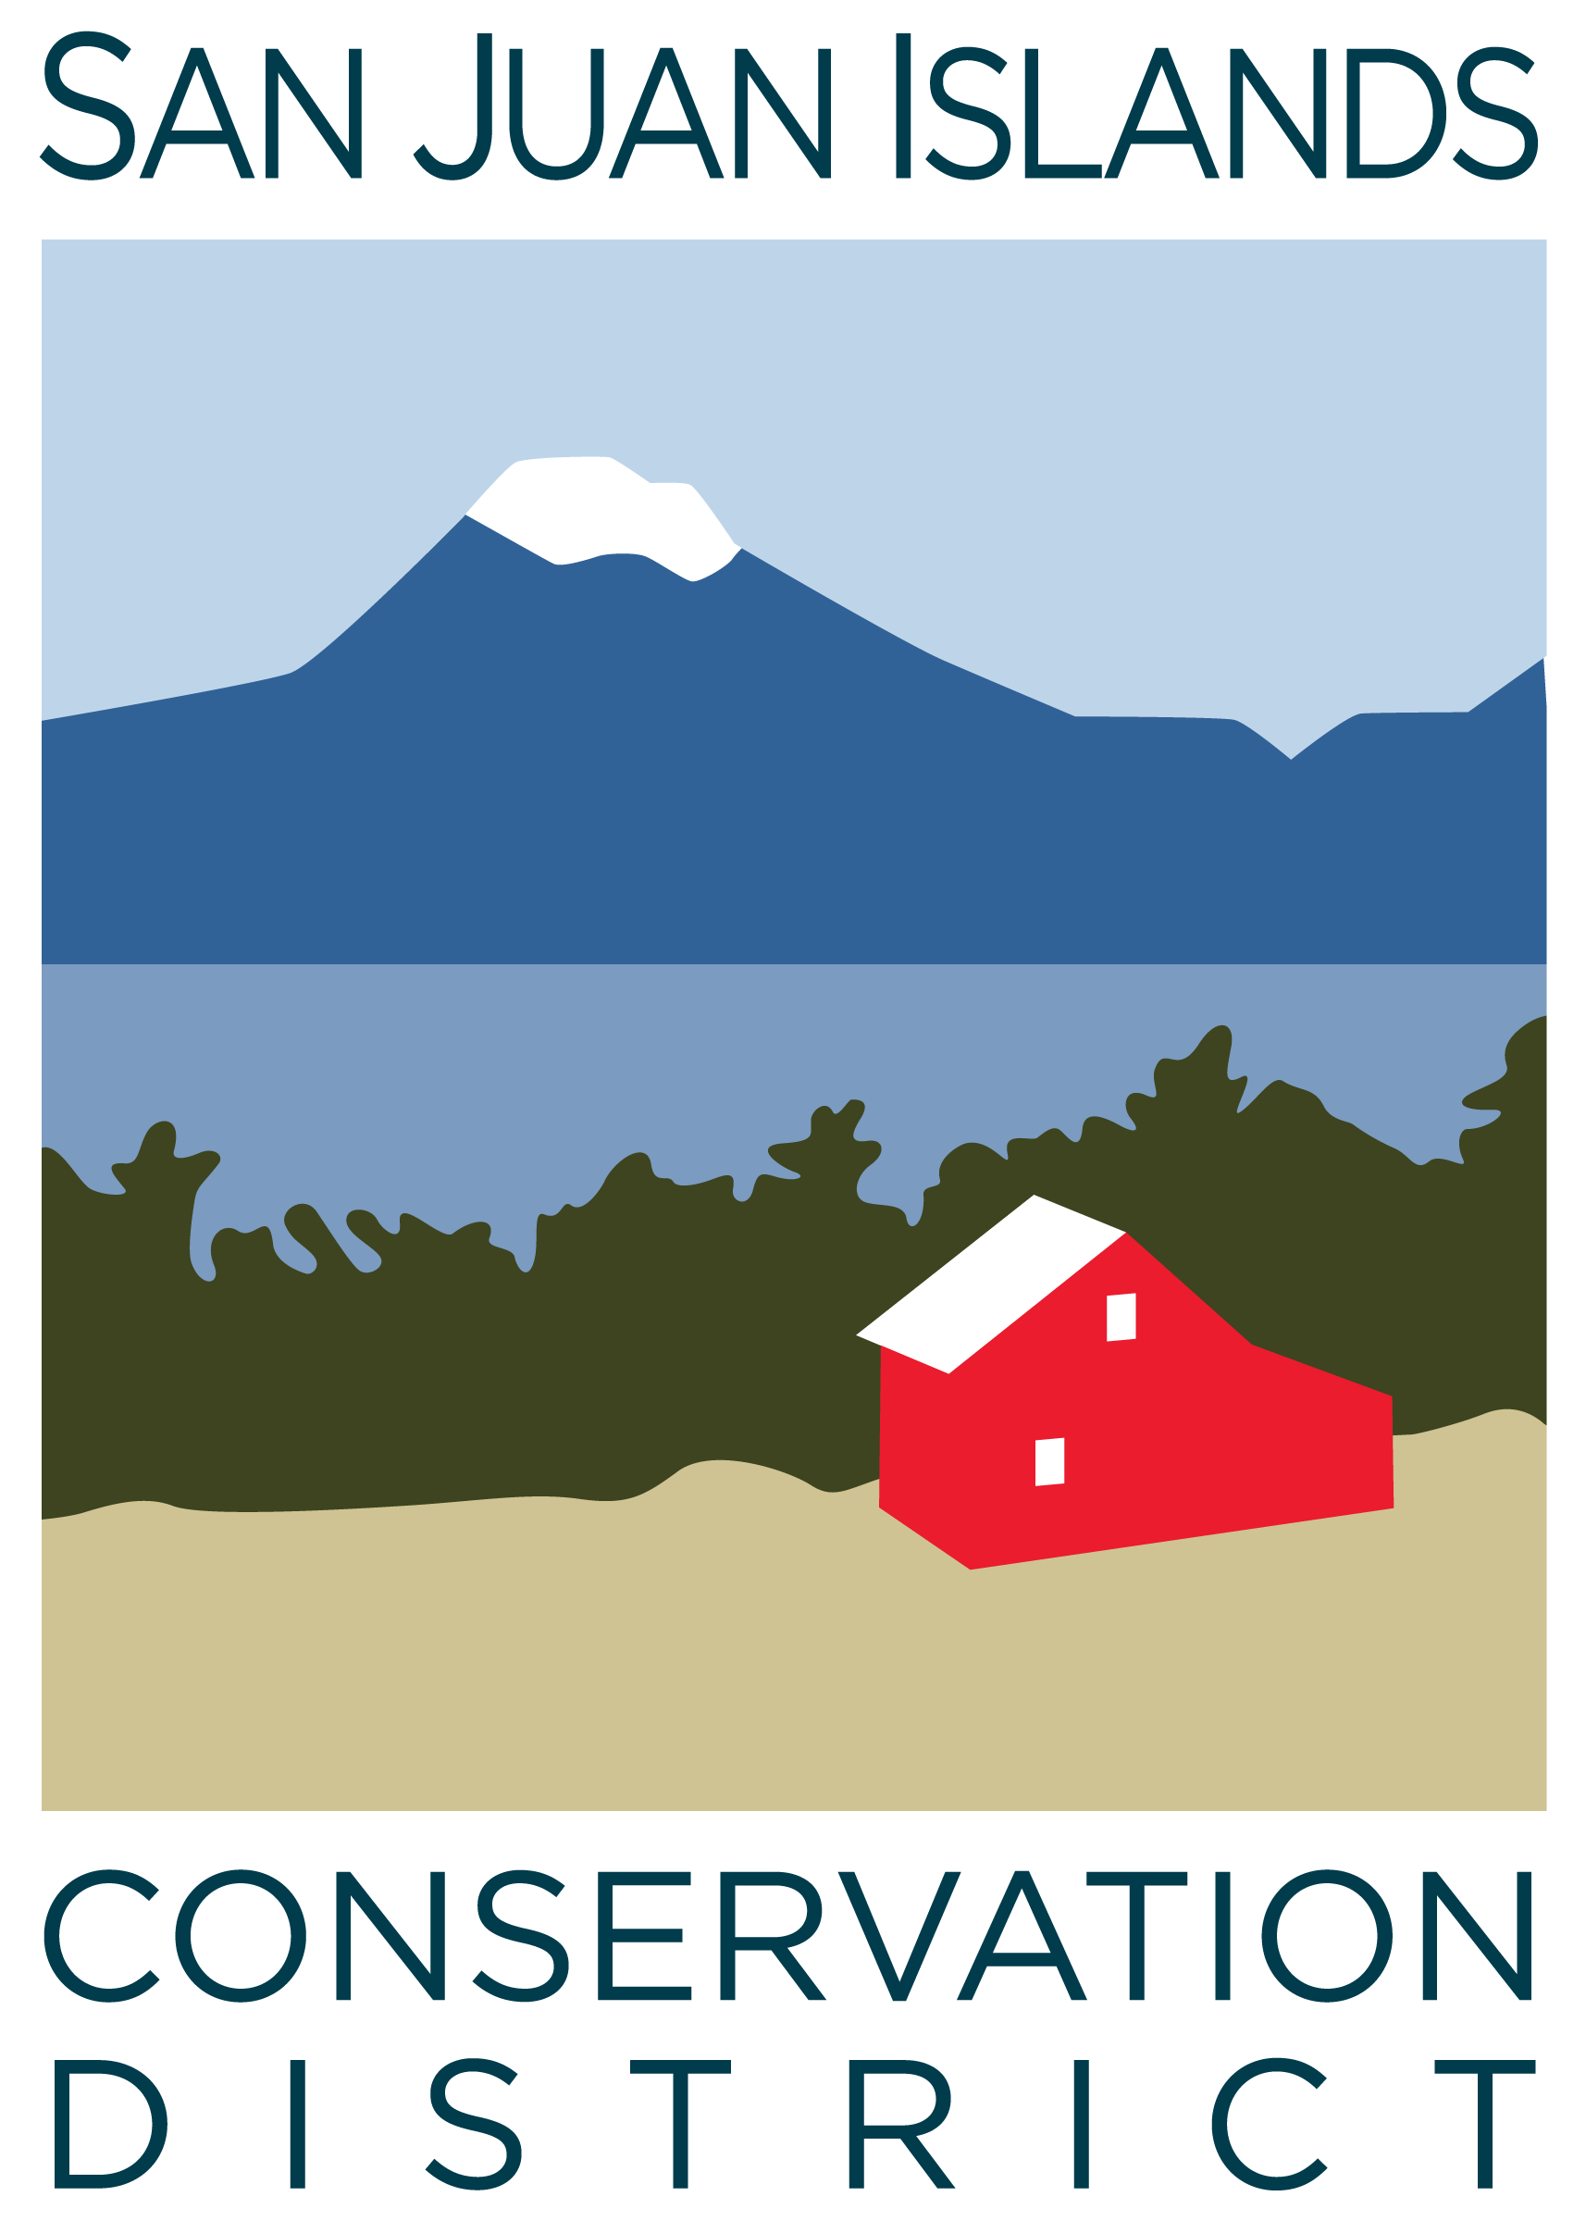
San Juan Islands Conservation District
BOARD OF SUPERVISORS
REGULAR MEETING MINUTES

Date: | June 27, 2025
Time: | 9:00am – 11:00am
Place: | 915 Spring St. Friday Harbor, WA 98250  And online via Zoom
Attending Supervisors: | David Bill, Lynn Bahrych, Vicki Heater, Claire Crawbuck, Roger Bairstow
Partners: | Jean Fike, WSCC Puget Sound Regional Manager, Alan Chapman, WACD NW Region Representative
Staff: | Paul Andersson, Tony Fyrqvist, Pauline Chiquet
Public: | Ronald Ames and Warwick Hubber

 | Welcome and Introductions
 | Welcomed Ronald Ames and Warwick Hubber from the Three Meadows Homeowners Association.
1 | Agenda Approval
 | The agenda was approved by consensus after the addition of public hearing regarding rates and charges under Agenda item – 6.
2 | Minutes Approval: May ’25 Regular Meeting
 | Action Item: Lynn made a motion to approve the May-25 Regular Meeting Minutes. The motion was seconded by Claire. The motion was approved.
3 | Public Comments
Ronald Ames and Warwick Hubber presented information about Three Meadows Homeowners Association covering:
- Unique property of approximately 200 acres of common land with mixture of forest and pasture.
- 28 families.
- Common land open to public.
- Substantial riparian areas and wetlands.
- 100 year old barn.
- Open to grazing at no cost.
4 | Partner Reports
Discussion:
WSCC, Jean Fike
- Closing biennium – Commission open for grant applications for next biennium
- WA Governor likely asking for additional cuts to budgets in the mid-biennium as tax revenue still lower than expected.
WACD, Alan Chapman:
- Plant Materials Center (PMC) raising prices reflecting higher costs.
- In Board Meeting discussed roles of Commission, WACD and Conservation Districts and the sustainable funding objective of the Districts.
5 | Financial Report – May Financials
 | Action Item: The Financial Manager reviewed the Financial Summary as presented. Lynn made a motion to approve the financial statements and was seconded by Vicki. The motion passed.
 | Discussion: While forestry funding is being cut the grant pipeline report demonstrated a large amount of riparian funding, ag funding and other grant applications out for review.
6 | Old Business
 | Action Item: Vicki made a motion to approve the cost share project limit increase from $50,000 to $100,000 for the Three Meadows Farm project and was seconded by Lynn. The motion passed.
Discussion:
- According to RCW 89.08.400 The County Legislative Authority/Conservation District shall hold a public hearing prior to the first day of August in the year prior to which it is proposed that the initial special assessments be collected. The proposal is to increase the annual per parcel rate to $25.00 as allowed by Substitute House Bill 1488 as signed into law by the Governor on 5/13/25.
- The Board will convene a special meeting on Wednesday 7/2/25 from 3:30pm-4:30pm to pass a resolution outlining the updated to the system of Rates and Charges. The board will convene a public hearing during its July Regular Meeting on 7/25.
7 | New Business
 | Action Item: Lynn made a motion to approve the Master Contract with WSCC. She was seconded by Roger and the motion was approved.
 | Action Item: Roger made a motion to approve the cost share and labor rate resolution as presented. He was seconded by Claire and the motion was approved.
 | Action Item: Lynn made a motion to approve all commission grant awards to the District for the biennium 2025-27. She was seconded by Vicki and the motion was approved.
 | Discussion: The updated Signature Form for the new biennium will be signed by all authorized signers. According to Jean Fike “wet” signatures are required.
 | Action Item: Roger made a motion approve creation of San Juan Community Foundation Endowment fund for YCC endowment campaign. He was seconded by Lynn and the motion passed.
8 | Staff and Program Reports
Discussion:
- Reviewed staff and program report.
9 | Recent & Upcoming Trainings/Webinars/Events
Discussion:
- Reviewed guest presentation and discussion on tribal engagement at Board and Staff Retreat on 5/28/25, with additional discussion regarding naming convention of various locations, particularly on Orcas Island and the different names assigned by Lummi and Haida. A tribal retreat was held at a private farm on Orcas Island.
- WADE Conference 69-11 was attended by Julie and Paul. It was an opportunity to learn through workshop and networking with employees from other Districts, Commission and WACD.
- WACD/WSCC Joint Meeting on 6/12/25 addressed the challenges and costs posed by Public Records Requests. Discussed RCW 42.56.070 – Documents and indexes to be made public – Statement of costs.
- VSP Technical Panel Visit to San Juan – discussed the successful site visits conducted at ag and riparian project sites around Orcas Island. Also discussed the designation of the Conservation District as the administrator of the VSP contract with WSCC, instead of San Juan County.
10 | Idea Pot
Discussion:
- Comments on groundwater resources and focusing attention on recharge analysis.
11 | Adjournment 11:00 am
Next Meeting: |  | Special Meeting – Friday July 2, 2025, from 3:30-4:30pm.  Regular Meeting - Friday, July 25, 2025, from 9:00am to 11:00am.

