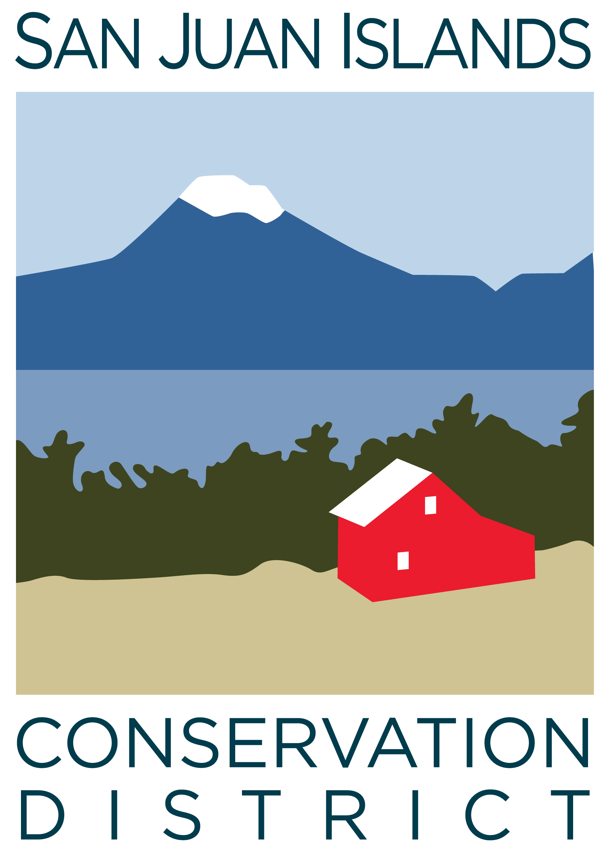
San Juan Islands Conservation District
BOARD OF SUPERVISORS
REGULAR MEETING MINUTES

Date: | March 3, 2025 (Feb-25 Board Meeting)
Time: | 1:30pm – 3:30pm
Place: | 915 Spring St. Friday Harbor, WA 98250  And online via Zoom
Attending Supervisors: | David Bill, Lynn Bahrych, Roger Bairstow, Vicki Heater, Claire Crawbuck
Partners: | David Rose, NRCS; Jean Fike, WSCC Puget Sound Regional Manager: Alan Chapman, Washington Association of Conservation Districts (WACD) NW Region Representative
Staff: | Paul Andersson, Tony Fyrqvist
Public:

 | Welcome and Introductions
1 | Agenda Approval
David called the meeting to order and the Agenda was approved by consensus after the following changes:
7 – New Business
- Added: Discussion – Update to SJICD Mission Statement
- Added: Discussion and Motion to approve Line of Credit
- Removed: Discussion – Board Self-Review
8 - Staff and Program Reports
- Added: Discussion on CWPP public draft
10 – Recent and Upcoming Trainings/Webinars/Events
- Added: Prescribed Fire public meeting- SJI Grange, March 13th at 5:30 pm; hosted by SJCLB with presentations by WA DNR.
- Added: SJICD Election – March 13, 9am-3pm, 915 Spring St.
2 | January ’24 Regular Meeting Minutes Approval
 | Action Item: Lynn made a motion to approve the 1/24/25 Regular Meeting Minutes. She was seconded by Claire. The motion was approved.
3 | Public Comments
 | None.
4 | Partner Reports
NRCS, David Rose
- Upgrades to payment software.
- Payments under farm bill and producer contracts.
- Inflation Reduction Act (IRA) funding is currently on hold.
- 2,700 applications statewide – record high.
- $7.8 million currently under obligated contracts in WA.
WACD, Alan Chapman:
- WACD financial results match projections.
- Small increase at Plant Materials Center (PMC) sales.
- Legislative Review and discussion on Puget Sound Caucus.
WSCC, Jean Fike
- WA State is projecting a budget shortfall of $12-15 billion over the next 4 years which will impact Conservation funding.
- Conservation Technical Assistance (CTA) had a one-time increase last year. Initially another increase was submitted to the Legislature, however, now the Commission is hoping to defend the existing level of funding.
- Conservation Accountability Performance Program (CAPP) is a combined mandatory and voluntary accountability and performance program for conservation districts composed of emailed checklists.
5 | Financial Report – December 2024 and January 2025 Financials
 | Action Item: Lynn made a motion to approve both Dec-24 and Jan-25 Financial Statements. She was seconded by Roger. In addition to the explanation of the Financial Summary a 24-month Equity graph was presented to the Board. The motion passed.
 | Discussion Item: Grant pipeline report.
6 | Old Business
 | Discussion Item: YCC budget, District commitment to the program, and scheduling the hiring of Crew Leaders and advertising for Crew Members.
 | Action Item: Vicki made a motion to adopt a 6-month 2025 YCC budget with the understanding that it can be amended in a limited fashion to reflect any changes in circumstances. Motion was seconded by Lynn. The motion passed.
 | Discussion of 2025 SJICD Election – Election date of Thursday March 13, 2025. David Bill is the only candidate on the ballot.
 | Discussion item: Rates and Charges under legislative activity and priorities.
7 | New Business –
 | Action Item: Lynn made a motion to approve the updated mission statement. Motion was seconded by Vicki. After discussion about abiding with federal rules when applying for federal grants it was deemed that further discussion is warranted and the motion was withdrawn.
 | Action Item: Claire made a motion to approve the renewal of Line of Credit with Liberty Bank. Vicki seconded and the motion passed.
 | Discussion Item: Diversity Equity and Inclusion (DEI) was discussed in light of requirements under certain grants, importance to staff and identifying underserved populations. The item was tabled for future discussion.
8 | Staff and Program Reports
Discussion: Community Wildfire Protection Plan (CWPP) “Public Draft” is being prepared with hopes of having a final version approved by the end of June 2025. The goal of the Plan is to mitigate the risk of wildfires in San Juan County and a completed plan is a requirement is a prerequisite for application of certain grants.
Program reports were summarized and comments were made regarding:
- The success of attaching eelgrass seeds to burrowing clams and cockles.
- Terrestrial Manager Group meeting.
- Dissolution of the San Juan Islands National Monument Advisory Committee.
9 | Subcommittees
 | - Subcommittees did not meet
10 | Recent & Upcoming Trainings/Webinars/Events
Discussion:
- The 2025 SJC Ag Summit had over 200 community members attend. It was considered a big success by the community and was attended/supported by several District employees.
- Arbor Day Celebration at Brickworks on 4/25/25 will be attended by members of the District.
11 | Idea Pot
11 | Adjournment 3:30pm
Next Meeting: |  | Regular Meeting - Friday, March 28, 2025, from 9:00am to 11:00am  Special Meeting – to be scheduled within the next two weeks.

