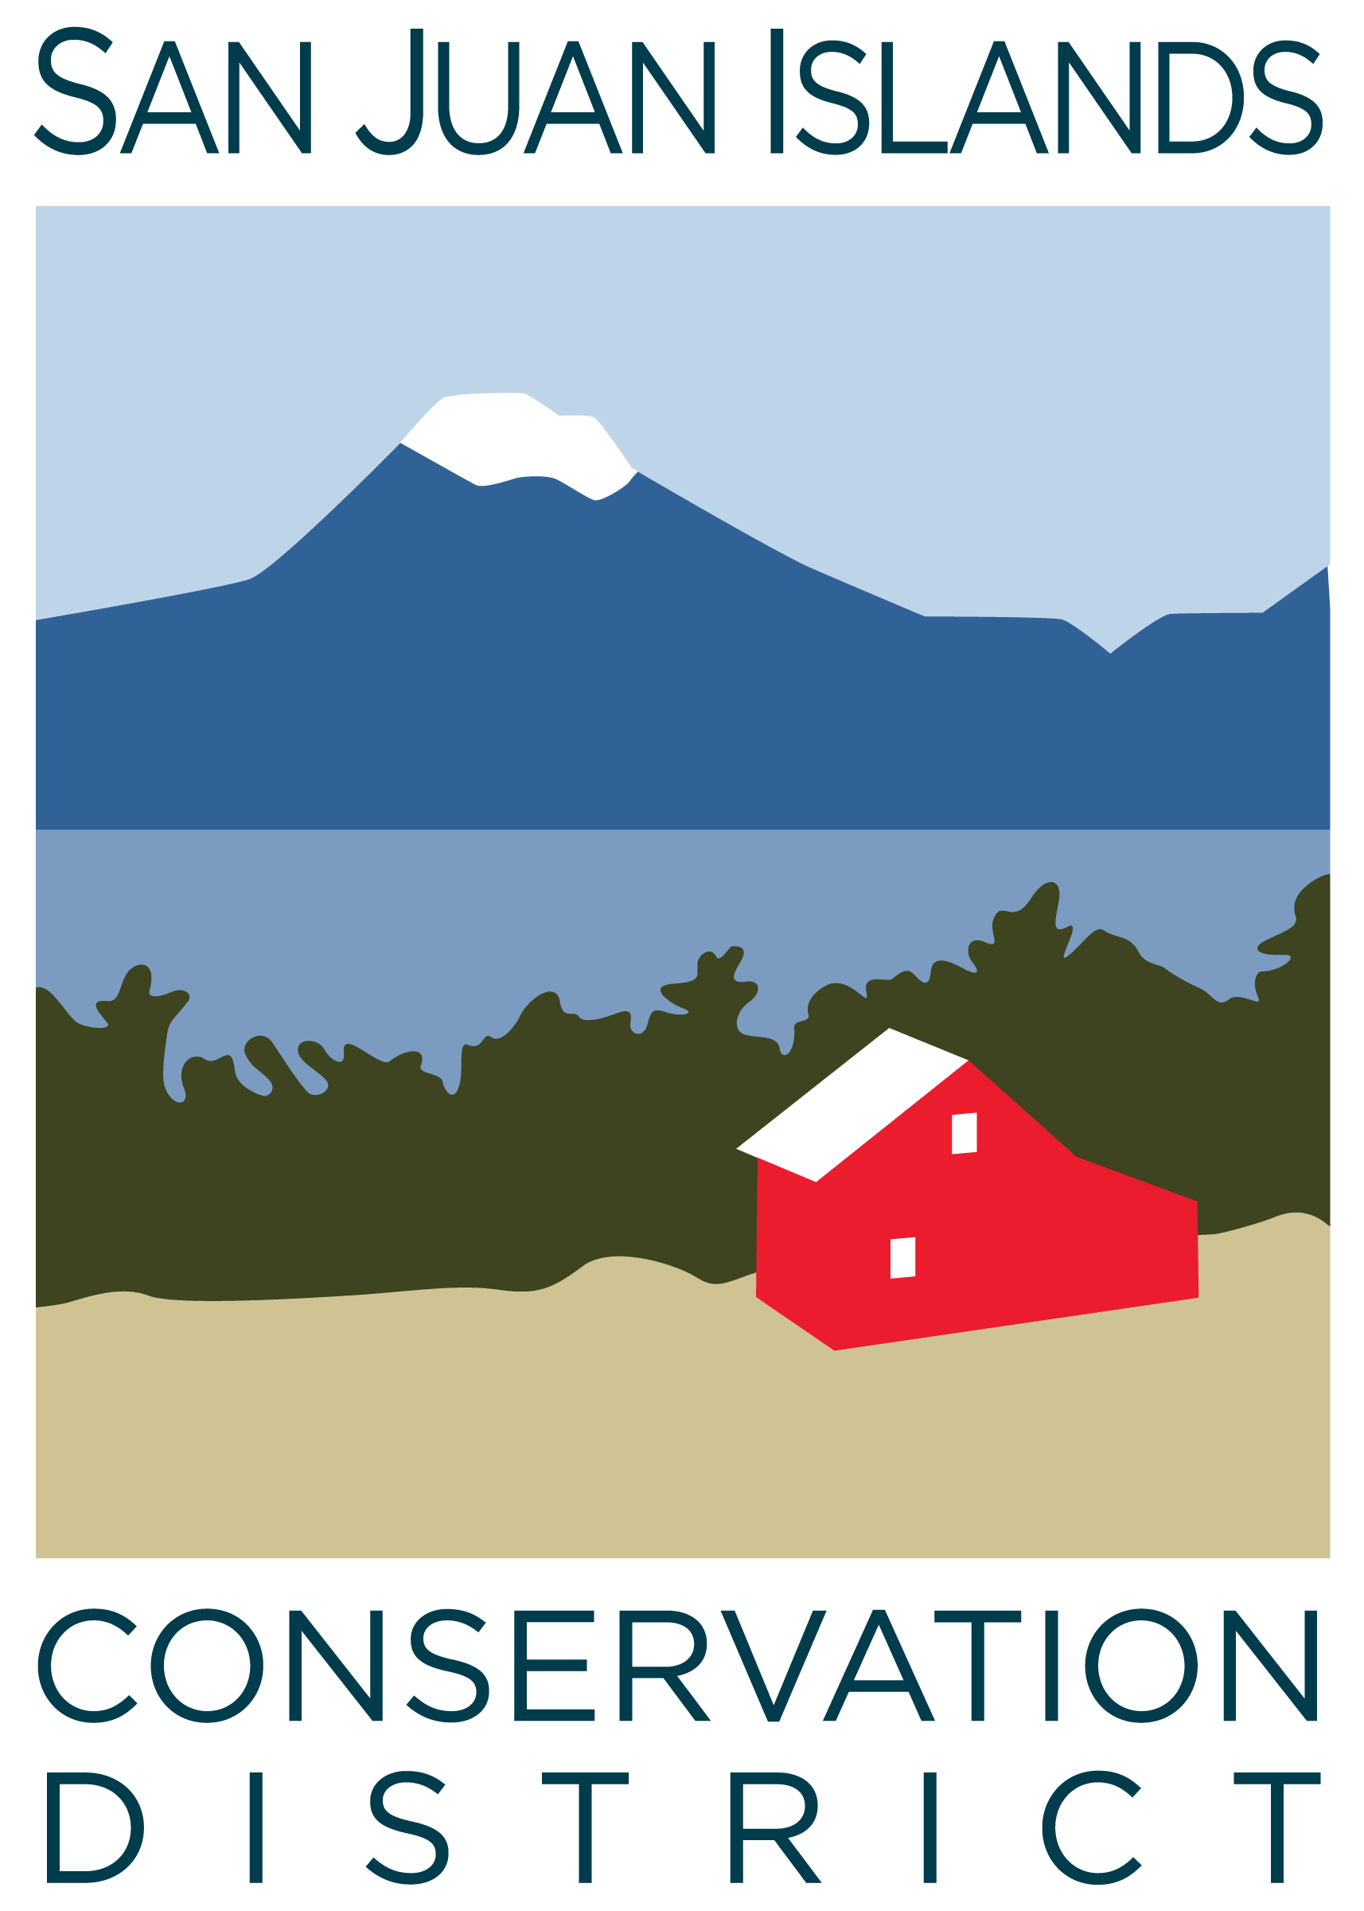
San Juan Islands Conservation District
BOARD OF SUPERVISORS
REGULAR MEETING MINUTES

Date: | January 23, 2026
Time: | 9:00am – 11:10am
Place: | 915 Spring St. Friday Harbor, WA 98250  And online via Zoom
Attending Supervisors: | David Bill, Lynn Bahrych, Vicki Heater, Claire Crawbuck
Partners: | Alan Chapman, WACD NW Region Representative; Robin Buckingham, NRCS
Staff: | Paul Andersson, Vicky Lewin
Public: | JT Haglund

 | Welcome and Introductions
1 | Agenda Approval
 | The Agenda was approved by consensus.
2 | Minutes Approval: December 19 Regular Meeting, January 9, 2026 Special Meeting
 | Action Item: Claire made a motion to approve the December 2025 Regular Meeting and January 9 Special Meeting minutes. The motion was seconded by Roger and approved.
3 | Public Comments
 | JT Haglund introduced himself as an Orcas Island landowner expressing interest in the Board of Supervisors position vacancy. JT is a permanent resident of Orcas with a long history of living on ag land and pursuing conservation goals. JT is currently working with SJICD on a riparian improvement cost share project.
4 | Partner Reports
Jean Fike, WSCC
- Governors proposed CTA budget cuts (~$600k for upcoming FY27)
- Bill to prevent CDs from land ownership not likely to succeed
- Rep Gregerson’s election bill has been introduced
- Reminder to not endorse a candidate on behalf of CD
Alan Chapman, WACD
- New committees – Shellfish, Ag Viability, CREP, Funding landscape, Ways and Means (to deal with 80 Resolutions in play)
- 2499 Elections bill – introduces 4-year term for board supervisors (recommendation of Joint Committee on Elections) and requires F1 financial disclosures by board supervisors (not a JCE recommendation)
- Monday Legislative Lunch sessions (virtual) held during session – Paul is attending
- Legislative day on the hill – Feb 10; Paul will attend
5 | Financial Report – Nov-25 Financials
 | Action Item: A motion to approve the December 2025 Payroll and Credit Card report was made by David and seconded by Vicki. The motion passed.
6 | Old Business
 | Discussion of March 18-19 WSCC Commission Meeting on San Juan Island tour and dinner Itinerary
 | Action Item: Vicki made a motion to approve Resolution 2026-001, SJICD 2026 Public Election. Motion was seconded by David and the passed.
 | Discussion of the February 6 board/staff retreat goals and agenda included a budget spreadsheet showing fixed costs and discretionary income and a plan to engage Lynn, Vicki, facilitator John Howell, and a staff person in a meeting to further scope the agenda.
7 | New Business
 | Discussion: The board discussed next steps for its self review and agreed to take up the topic at the upcoming 2/6 board and staff retreat.
 | Discussion: The board discussed cost-share project award criteria including annual income of award recipients and other factors that could impact decision-making. SJICD Cost Share policies currently focus funding toward resource needs and opportunities for improvement, regardless of landowner/operator income. No changes to policy were made.
8 | Staff and Program Reports
- Staff and Program Report was provided to the board.
- There was further discussion of closure of the eelgrass restoration program, biochar kiln workshops, and ICC business model without AmeriCorps.
9 | Recent & Upcoming Trainings/Webinars/Events
- Legislative Day on the Hill – February 10
- Biochar kiln community workshops – January 21 (MB Farms, SJI), January 25 (JB Farms Orcas), February 21 (Overmarsh Commons, SJI), February 22 (Midnight’s Farm, Lopez)
- SJC Agricultural Summit – February 27, 28
- WSCC Commission Meeting – March 18, 19
- SJICD Election – March 26
- Climate Convergence, April 2, Brickworks
10 | Executive Session – to discuss the performance of a public employee
 | Executive Session began at 10:50 and adjourned at 11am.
 | Regular Meeting resumed at 11:00.
 | Action: David made a motion to approve sending of a final letter to the Executive Director summarizing the board’s annual performance review. The motion was seconded by Roger and approved.
11 | Adjourn Regular Meeting 11:05 am
Next Meeting: | Regular Meeting - Friday, February 27, 2026, from 9:00am to 11:00am.

