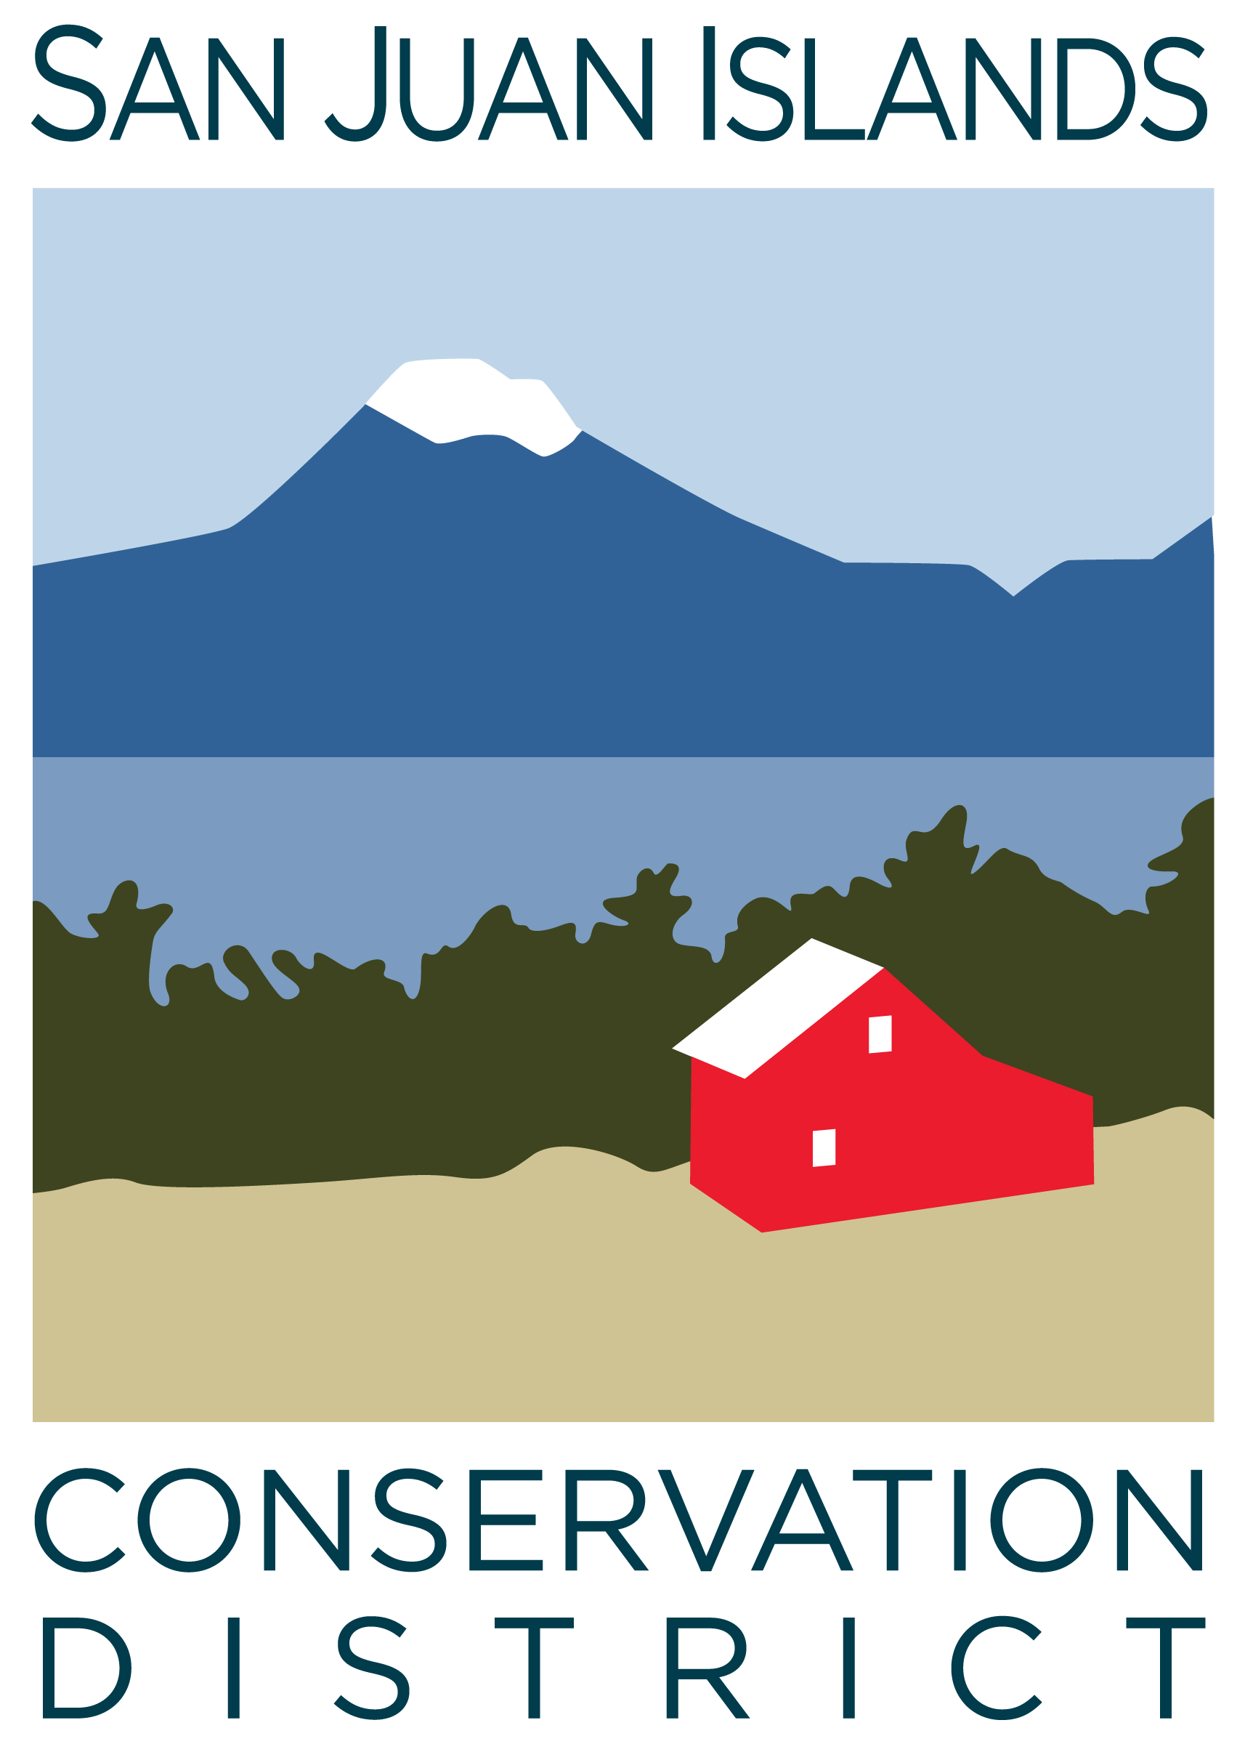
San Juan Islands Conservation District
BOARD OF SUPERVISORS
REGULAR MEETING MINUTES

Date: | April 19, 2024
Time: | 1:00pm – 1:10pm
Place: | 530 Guard Street, Friday Harbor, WA 98250  And online via Zoom
Attending Supervisors: | Carson Sprenger, David Bill, Vicki Heater, Lynn Bahrych, Claire Crawbuck
Attending Associates:
Absent:
Partners:
Staff: | Paul Andersson, Tony Fyrqvist
Public:

1 | Agenda Approval
2 | Action Item – Motion to approve Resolution 2024-003 pertaining to USDA RD form 1942-9 Loan Resolution Security Agreement
 | Action item: David made a motion to approve Resolution 2024-003 pertaining to USDA RD form 1942-9 Loan Resolution Security Agreement dated April 19, 2024. The Resolution authorizes and provides for the incurrence of indebtedness by San Juan Islands Conservation District in the principal amount of $870,000.00 for the purpose of providing a portion of the cost of acquiring an office building. The terms of the loan outlined in the document include the interest rate of 3.5000% per annum with principal and interest payments over 35 years. A copy of the Agreement with all pertinent details was presented. The second was provided by Lynn. The motion was passed unanimously 5 – 0 and the form will be signed by the Chair of the Board, attested by the Executive Director and certified by the Vice Chair of the Board.
12 | Adjournment 1:10pm
Next Meeting: |  | Regular Board Meeting Friday, April 26, 2024 from 8:30am to 10:30am

