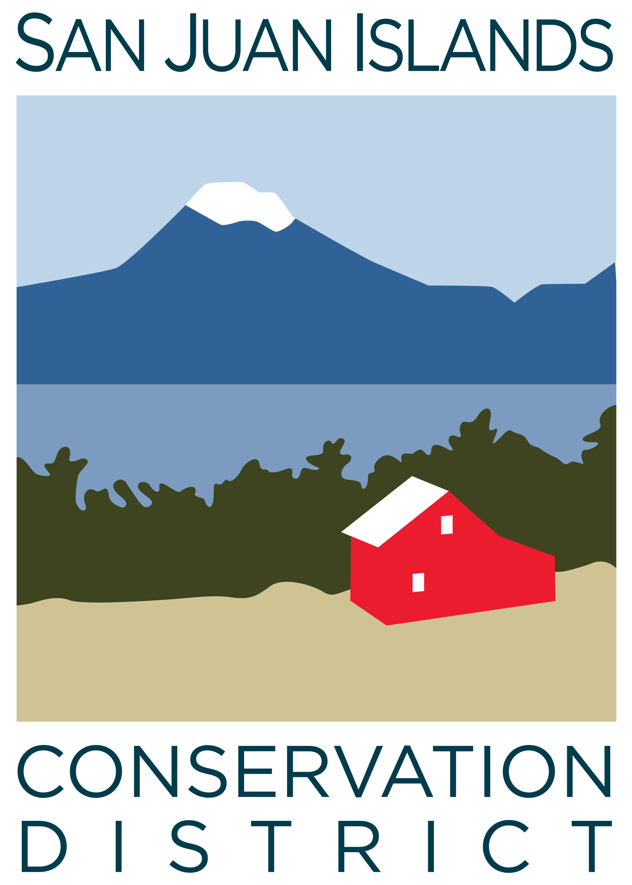
San Juan Islands Conservation District
BOARD OF SUPERVISORS
REGULAR MEETING MINUTES

Date: | October 24, 2025
Time: | 9:00am – 11:00am
Place: | 915 Spring St. Friday Harbor, WA 98250  And online via Zoom
Attending Supervisors: | David Bill, Lynn Bahrych, Vicki Heater, Claire Crawbuck
Partners: | Jean Fike, WSCC Puget Sound Regional Manager, Alan Chapman, WACD NW Region Representative
Staff: | Paul Andersson, Tony Fyrqvist, Cathi Winings, Pauline Chiquet
Public: | Linda Lyshall

 | Welcome and Introductions
1 | Agenda Approval
 | Action Item: David made a motion to approve the Agenda and was seconded by Claire. The motion was approved.
2 | Minutes Approval: September 25 Regular Meeting
 | Action Item: David made a motion to approve the September-25 Regular Meeting Minutes. The motion was seconded by Claire and approved.
3 | Public Comments
 | Discussion: Linda Lyshall complimented the District for recent action on Rates and Charges. The County Council supported the District’s request. It was mentioned that the district reinforces San Juan County’s objectives with engaging in tasks which the County then does not have to complete.
4 | Partner Reports
Discussion:
WSCC, Jean Fike:
- Reminded of the last day to vote for the next West Side Representative for the Commission.
WACD, Alan Chapman:
- In the last WACD meeting discussed: 1) Dues which have been flat for the past 7 years, and smaller Districts have stated that the WACD benefits might not be equally distributed. Also, inflation impact on the dues along with District funding from Rates and Charges will be evaluated within the bylaws. 2) The 26-27 Annual Meeting will be at Skamania Lodge on Columbia River and will include Saturday to enable Supervisors who work during the week to attend. 3) The Ways and Means Committee will review resolutions and provide input to staff on how to best implement priorities.
- The Board extended appreciation to Alan for agreeing to remain as the WACD NW Region Representative.
5 | Financial Report – Sep-25 Financials
 | Action Item: The Financial Manager reviewed the 9/30/25 Financial Summary as presented. Detailed Income Statements and Balance Sheets for 7/31/25, 8/31/25 and 9/30/25 were not available due to the District working on the upgrade to the accounting system. However, the bank account balances, receivables, invoicing and loan balance information were verified when incorporated into the Financial Summary. The District is evaluating an additional amount to be transferred to reserves in order to maximize interest earnings and to mitigate financial risk due to the FDIC limit of $250,000 in insured deposits. We will evaluate the returns from local financial institutions against LGIP (Local Government Investment Pool). David made a motion to approve the Credit Card Details and Payroll reports and was seconded by Vicki. The motion passed.
 | Discussion: Executive Director discussed the Grant Pipeline Report, noting additional $6,000 grant application for YCC and a $60,000 grant application for smoulder detection equipment. The generosity of the anonymous donor through the Community Foundation of Northeast Florida is greatly appreciated. The funds have been put to great use to benefit the community as the District now has a Development Officer and has been able purchase vehicles and a vessel.
6 | Old Business
Discussion on Rates and Charges update: The updated Rates and Charges will go into effect in January 2026 and will be in effect for 10 years. The additional funding will provide stability to the District and can be used in underfunded areas such as Admin, Communications, Forestry and YCC.
Additional funding can also be used to build up reserves to cover 3 months of payroll.
SJICD was the first district in the region to initiate action in Rates and Charges in response to the change in State law.
The Board will continue to evaluate how to most beneficially allocate any additional funding.
Discussion on WACD NW Regional Meeting: WACD NW Area Meeting was attended by Lynn and Paul. Two resolutions were passed and the two other ones were concerned about establishing a new CREP program for Washington, and requiring net 30 days for payment on district invoices sent to Conservation Commission. Generally the Commission is prompt in submitting payments on District invoices.
Per acre fees charged by counties for conversion of Agricultural land to residential land were discussed within the Illinois and Missouri models.
The topic of an Elections Bill is resurfacing with:
- F-1 financial disclosure by board members.
- Participation in the general election ballot.
- 4 year terms for supervisors making elections necessary only every other year, instead of every year.
7 | New Business
Discussion on Farm/Forest Plan Wait List and Proof of Performance Reporting:
- Current wait list has 25 farm plans and 20 forest plans.
- Historically the District has completed 133 farm and forest plans with a goal of 12/yr.
- Proof of performance with verification of that state funds have been well spent is deemed crucial on cost share projects - with a neutral and reliable verification process.
- Well monitoring kit technology could be rented out by the District.
- Irrigation metering can be implemented with results reported back to the District.
Action Item: David made a motion to approve the following 2 cost share projects for funding which are in excess of $50,000:
- Saturn’s Return Farm agroforestry project at 75% of actual costs up to $72,037.50.
- Two Barn Farm waste storage and heavy use area at 75% of actual costs up to $94,619.50.
The motion was seconded by Lynn and approved after discussion of the cost benefit analysis of funding multiple smaller projects vs a few larger ones. The Saturn’s Return project will be a model for future agroforestry projects.
8 | Staff and Program Reports
Discussion: Staff Member Cathi Winings presented Forest Stewardship Program Updates with topics covering:
- Budget overview.
- Program highlights, including Wildfire Ready Neighbors visits; Wild Rose Fire collaboration; forest health consultations; and Community Wildfire Protection Plan next steps.
Discussion:
- District will be purchasing 3 biochar kilns with SFF funding which will be rented out and used in workshops.
- “Community Chipper Days” are supported by the District.
- Cathi Winings received commendation from a Land Bank staff member for her diligent work.
9 | Recent & Upcoming Trainings/Webinars/Events
 | Listed on the Agenda.
10 | - Idea Pot
Discussion:
- Discussion on ways to measure agricultural water use.
- The Conservation District is a crucial component in implementing the climate action plan outlined by the Climate Sustainability Committee. The goals and policies of the Committee will lead to improved regulations.
- Discussion on designated forest land qualifying as open space.
11 | - Adjournment 11:00 am
Next Meeting: | Regular Meeting - Friday, November 21, 2025, from 9:00am to 11:00am.

