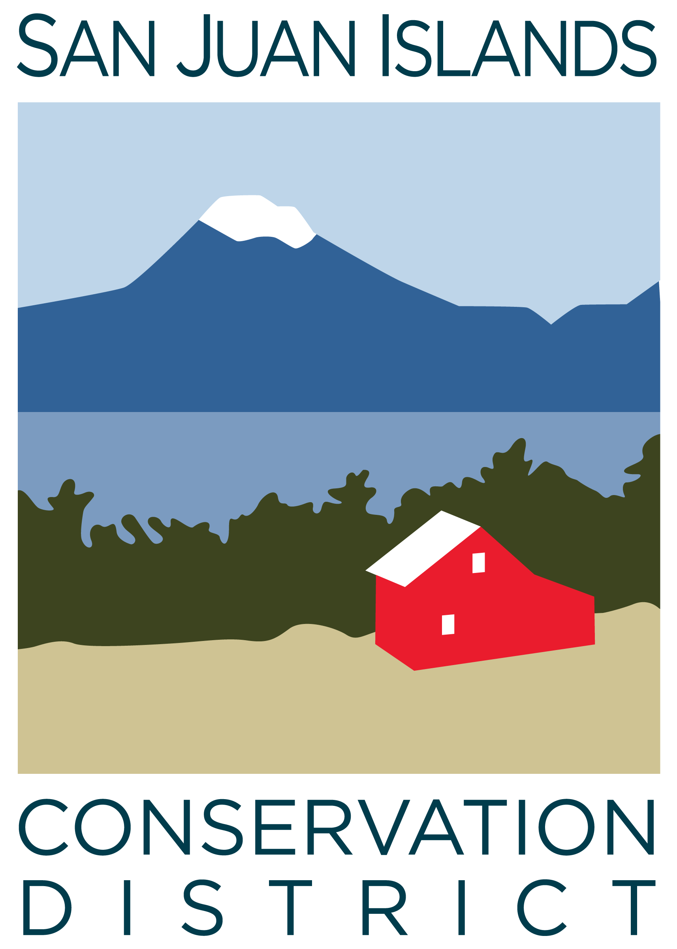
San Juan Islands Conservation District
BOARD OF SUPERVISORS
REGULAR MEETING MINUTES

Date: | May 22, 2026
Time: | 9:00am
Place: | 915 Spring St. Friday Harbor, WA 98250  And online via Zoom
Attending Supervisors: | David Bill, Lynn Bahrych, Vicki Heater, Claire Crawbuck, Andrew Jones
Partners: | Alan Chapman; WACD NW Region Representative
Staff: | Paul Andersson, Tony Fyrqvist, Heidi White, Julie Curtis
Public: | Roger Bairstow

 | Welcome and Introductions: Lynn called the meeting to order at 9:07am.
 | The board welcomed new board supervisor Andrew Jones. His position was just confirmed by WSCC. Andrew gave a brief introduction.
1 | Agenda Approval
 | Additions to the agenda: Lynn added a discussion regarding potentially making Roger Bairstow an Associate Supervisor. David asked to discuss the San Juan County’s budget deficit. The Agenda was approved by consensus.
2 | Partner Reports
WACD, Alan Chapman discussed:
- WACD had a board meeting last week. Draft work plan is available on the Hub. Alan asked board supervisors to review and provide feedback before their June meeting.
- Draft budget not yet available, but Plant Material Center revenues are down and cuts are expected
- WACD Ways and Means subcommittee looking at ways to provide policy guidance for staff when there is not an official resolution in place and a legislative issue comes up that districts ask WACD to respond to quickly.
- Ongoing discussions regarding elections legislation next steps.
- Alan will send a link to SJICD supervisors to attend the June meeting
3 | Minutes Approval: April 24 Regular Meeting Minutes Approval
 | Action: David made a motion to approve the April 24 Regular Meeting Minutes. The motion was seconded by Claire and approved unanimously.
4 | Public Comments
 | Outgoing board supervisor Roger Baristow thanked the board and Paul for their leadership and for the opportunity to be on the board. Roger said he feels the district has both strong board leadership and strong executive leadership and the two are not afraid to have difficult conversations for the best possible outcomes. He believes the district is in a better place than many smaller non-profits he has experienced because of this. He said he is open to learning about what would be involved with being an associate supervisor.
5 | Financial Report – July 2025 – April 2026 Financials
Financial Manager Tony Fryrqvist reported:
- County tax revenue at the new assessment rate was received.
- The 2024 single-year audit has wrapped up. The loan for purchasing the building should have been reported as revenue, so the auditor requires that the financial statements be corrected to reflect this. The final audit report should be available by the next board meeting.
- Financial Edge software; Vicky Lewin is working full-time on conversion to Financial Edge.
- Account balances are stable but financial statements are not available yet.
- Lynn asked about potentially using reserve funds to pay down the mortgage in order to avoid federal thresholds requiring annual audits which cost $25,000-$30,000. Staff hope to be below the federal audit threshold next year without contributing reserve funds to pay down the mortgage and recommended keeping surplus funds in investments instead of paying down the mortgage if possible.
Action:
David made a motion to approve payroll and credit card statements for April 2026. Claire seconded the motion and it was approved unanimously.

6 | Old Business
Motion to Approve FY2027 Annual Work Plan and Budget
- Paul presented the draft work plan, with suggested edits from Vicki Heater. The board discussed the draft and made minor revisions.
- The Board discussed the idea of revisiting the budget and work plan half-way through each year to help track progress.
Action: Lynn made a motion to adopt the annual work plan and the FY2027 budget with changes presented. David seconded the motion.
Discussion: Paul presented the FY2027 budget, including projected salary calculations with anticipated new positions. David reported that Ag funding previously provided by the County may disappear with the County’s budget cuts. The board discussed SJICD’s role in filling the void, including utilizing increased revenue from rates and charges to provide increased support for Ag viability.
Action: Lynn suggested a sub-committee to continue discussing this issue: David and Andrew will work with Paul and bring suggestions to the June board meeting.
Action: After discussion, the motion to approve the annual work plan and FY2027 budget was approved unanimously.

Motion to approve Programs Director position and updated Organization Chart
- Paul reviewed the governance policy, which states that the board must approve an Organization chart. Paul presented the proposed re-structured Organization chart. One of the goals is to reduce direct reports under the executive director.
- Action: Claire made a motion to approve the org chart and programs director position as presented. David seconded the motion.
Action: After discussion, Lynn rescinded her earlier motion to approve the org chart and programs director position.
Action: Vicki made a motion to approve the org chart as presented, with the intent to complete a more in-depth review of job descriptions and job titles at a later date. Claire seconded the motion and it passed unanimously.
Action: After further discussion, David made a motion to approve the Programs Director position. Claire seconded the motion and it passed unanimously.

7 | New Business
Welcome to new CD Supervisor Andrew Jones: Andrew was welcomed to the CD board on the heels of 2026 election results being certified by WSCC this week. Andrew’s onboarding will continue with logistics, trainings, and conversations with staff, board and WSCC.
Discussion of Roger Baristow as Associate Supervisor: Paul noted that Associate Supervisors cannot receive cost-share and that significant cost-share project work has been underway at Roger’s farm so establishing him as an Associate Supervisor is not advised.
Policy Review – Governance policies
Lynn suggested supervisors review the governance policies on their own and come back to a meeting with individual suggestions. Paul offered to be on a sub-committee with Lynn and Vicki to review.

8 | Staff and Program Reports
Staff presentation on Communications and Development-
Julie Curtis presented to the board. She gave part of this presentation at the climate convergence conference.
Other discussions on Program Reports were postponed due to time constraints.
9 | Recent & Upcoming Trainings/Webinars/Events
 | - See agenda. Event info is available online.
10 | Idea Pot
- Lynn will email everyone with County info regarding their integrated water resource management plan.
- Land and property donations: Paul reported that a landowner expressed interest in donating a house and land in Friday Harbor to the Conservation District in order to allow the land to become a small public park. Paul is following up to obtain more information.
11 | Adjourn Regular Meeting Lynn adjourned the meeting at 11:05am

