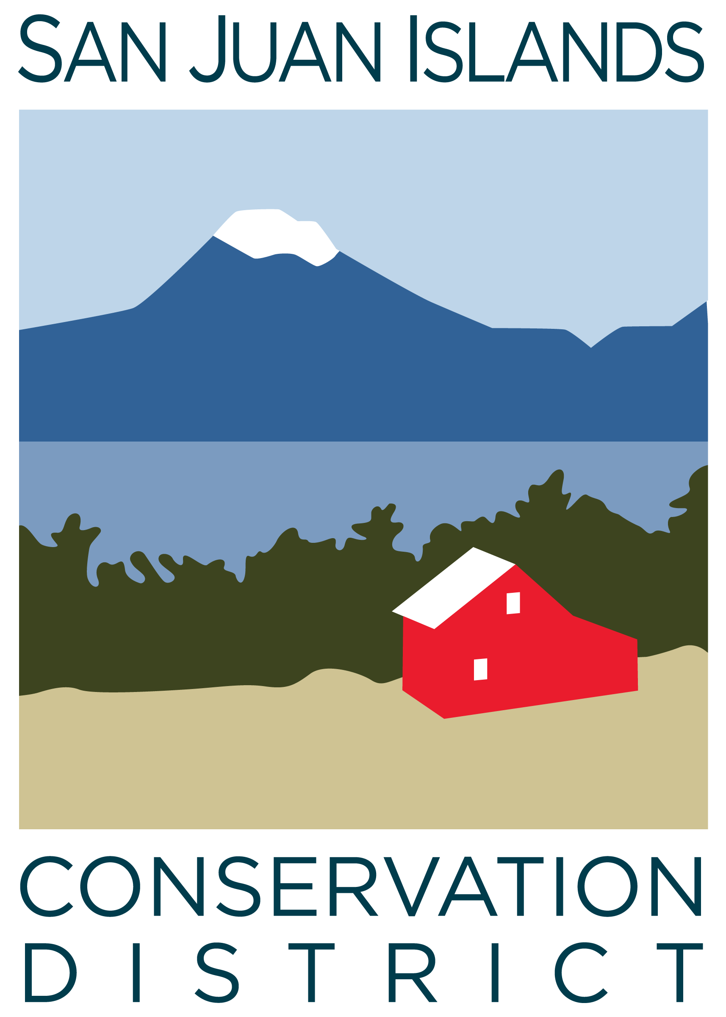
San Juan Islands Conservation District
BOARD OF SUPERVISORS
REGULAR MEETING MINUTES

Date: | August 28, 2026
Time: | 9:00am
Place: | 915 Spring St. Friday Harbor, WA 98250  And online via Zoom
Attending Supervisors: | David Bill, Lynn Bahrych, Vicki Heater, Claire Crawbuck, Andrew Jones
Partners: | Alan Chapman; WACD NW Region Representative, Lora Liegel; WSCC Northwest Regional Manager
Staff: | Paul Andersson, Tony Fyrqvist, Heidi White, Vicky Lewin, Adam Martin, Zoey Smith
Public: | None

 | Welcome and Introductions: Lynn called the meeting to order at 9:00am. Roundtable of introductions, including new SJICD Programs Director Adam Martin, and new WSCC Northwest Regional Manager Lora Liegel.
1 | Agenda Approval
 | Paul added to the Events Section of the Agenda: WACD Legislative Engagement Meeting on September 18. He said he will attend virtually. Action: The Agenda was approved by consensus.
2 | Minutes Approval: June 26, 2026 Regular Meeting Minutes Approval
 | Action: David made a motion to approve the June 26, 2026 Regular Meeting Minutes. The motion was seconded by Andrew and approved unanimously.
3 | Public Comments
 | None.
4 | Partner Reports
Paul reported that Robin Buckingham of NRCS has stepped down.
- Many districts are being asked by NRCS to provide information regarding board member affiliations or occupations for an NRCS civil rights audit. SJICD has not been asked to provide this information.
Alan Chapman of WACD provided a written report that was viewed and discussed.
Lora Liegel, WSCC reported:
- WSCC September 17th meeting is hosted by Underwood CD. Typically, there is a tour and dinner the night before and the business meeting the next day. Virtual attendance is an option.
- Sept 10th is the next round-table meeting; expecting an update from the OMBUDS working group regarding proposed updates to the Grant Policy and Procedures manual.
- Sept 29th from 10am – Noon is the required elections training for districts. SCC has been examining the WAC related to the elections processes.
*Paul noted that he is the elections supervisor and will attend, along with Heidi and Vicky Lewin.
- Legislative funding requests for the 2027-2029 biennium are being considered, inclusive of feedback from surveys sent out to CDs. Draft versions of decision packages were sent out to district managers last week. Feedback sought by September 1st.
- NW area meeting for WACD is October 14.
5 | Financial Reports
Financial Manager Tony Fyrqvist reviewed the finance report with the board:
- Vicky has been working extensively with new financial software.
- This month led to a low operating account balance due to a large cost-share payments and a delay in receiving RGP grant funds due to complexities in invoicing.
- The district had to dip into reserve funds and transferred $50,000 from LGIP reserve account to Banner Bank operating account. This is the first time the district has had to take funds from reserve in order to process payroll and cover expenses.
- Anticipate being able to return the $50k to reserve once reimbursement is received from the Commission for the cost-share payment, and various outstanding invoices to grantors. Paul noted that $50k is the max that Executive Director and Finance Manager can withdraw from reserves without board pre-approval.
The board discussed the possibility of removing the line of credit that the district currently has access to when its term ends next year.

Status check on Financial Edge Software Transition:
Paul reported:
- Vicky is working on clearing out and consolidating more than 1,000 accounts that were created during the transition to Financial Edge, with a goal of getting closer to 100 accounts. This has impacted the ability to produce an income statement properly. Once the Chart of Accounts is updated, reporting should be cleaner.
- Also hoping to take on an expense management platform that would allow staff to upload receipts directly into Financial Edge

Action:
David made a motion to approve the July 5th and August 5th Payroll and the June 1 – July 31 Expense Report. Vicki seconded the motion and it was approved unanimously.

Grant Progress and Pipeline Reports
- Paul reviewed the Grant Contract Pipeline Report and discussed new grants received since the board last met. The district currently has approximately $2.7 million in contracted funds available to spend down.
- Discussion of No-Till Drill and whether the district should figure out a way to support separate uses of the drill: no-till and till. The grant-funded/subsidized use can only be for no-till. Some users have been using it for tilling.

USDA Loan Pay-down Analysis:
Paul reported that the District’s projected federal revenue for 2026 totals approximately $1.14 million
Likely would need to pay down $200-$300k from reserve funds on the building loan to fall below the federal audit threshold of $1 million. The single-year federal audit was costly in terms of funds and staff time.

6 | Old Business
Policy Subcommittee – Motion to approve Governance policy updates and Gift Receiving Policy:
The board reviewed proposed edits to the Governance Policy
Action: Claire made a motion to approve the Governance Policy as presented. David seconded the motion and it passed unanimously.
Review and discussion of proposed new Gift Acceptance Policy. Draft language came from the San Juan Preservation Trust. No action - further review at September meeting.

7 | New Business
 | New Staff/Partner introductions – done at the beginning of the meeting.
VSP 10-year report – Discussion of final conclusion by WSCC
Paul reported that the Review committee tech panel consensus was that the district is doing fantastic at meeting goals. SJICD staff have been working on a slideshow and presentation for San Juan County Council.
Property Easement Discussion – Port of Friday Harbor parcel
Paul reported that the Port of Friday Harbor is developing the neighboring property next to the office. It will be the home office of the residential developers that are constructing homes at Roche Harbor. The board reviewed a rendering of the proposed building. Currently, SJICD parking area crosses over the property line. The Port is seeking an easement to allow access to their property and to formalize the district’s driveway, which exists on the Port’s property. Formal easement language will be forthcoming for board review and approval.

County Funding Subcommittee – Discussion of SJICD support of un-funded County programs
David, Andrew, and Paul met to discuss any District response to County funding cuts. Paul gave verbal commitment to the County to provide $5-10k in from the district to maintain the Ag Resources Committee (ARC) coordinator position as it currently exists with the County. The Land Bank also offered to contribute.
Policy Subcommittee - Discussion of Employee Handbook updates
Paul reported: Heidi worked on drafting proposed updates to the Employee Handbook, and incorporated staff feedback. The board subcommittee met and reviewed the first draft. Paul and Heidi will continue working on it. Heidi will write a summary of proposed updates to streamline review for at the September board meeting. Lynn recommended board members set aside 2-4 hours to review the proposed draft.

Paul noted that Kai is dropping his hours to 24 hours per week. Part-time employee classification needs better clarification in terms of paid leave and benefits. Updating the employee handbook should address this.
 | Lynn reported: The newly released “State of the World's Plants and Fungi 2026” report has contributions from our very own Adam Martin!
8 | Staff and Program Reports; discussion and review of report. Paul reported that YCC had one of their best seasons ever.
9 | Recent & Upcoming Trainings/Webinars/Events
- See agenda for events
- SJC Fair was awesome! Thanks to everyone who volunteered at the booth
- Farm Tours are coming up
10 | Idea Pot
 | - Vicki Heater reported that Dona Wuthnow sent a letter to the CWPP stakeholders, including the district, calling into question forestry and Firewise practices. The board reviewed the letter. Paul said the CWPP stakeholder group is providing a draft response and an invitation to Dona to visit a site. Vicki discussed improving community outreach and communication regarding benefits of burn practices.
11 | Adjourn Regular Meeting Lynn adjourned the meeting at 11:13 am

