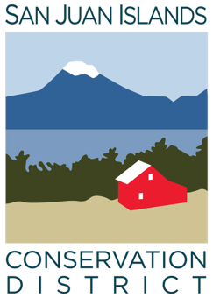
San Juan Islands Conservation District
BOARD OF SUPERVISORS
Special MEETING MINUTES

Date: | February 6, 2026
Time: | 9:00am – 1:15pm
Place: | 915 Spring St. Friday Harbor, WA 98250  And online via Zoom
Attending Supervisors: | David Bill, Lynn Bahrych, Vicki Heater, Claire Crawbuck, Roger Bairstow
Partners: | Jean Fike (WSCC), John Howell (Facilitator)
Staff: | Paul Andersson, Kai Hoffman-Krull, Pauline Chiquet, Tony Fyrqvist, Julie Curtis, Cathi Winings
Public: | None

1 | Agenda Approval
 | The Agenda was approved by consensus.
2 | Introductions, Purpose, Retreat Goals, and Conversation Norms
3 | Organizational Development Needs Discussion
4 | Making Organizational and Operational Improvements
5 | Working Lunch
6 | Summary and Next Steps
7 | Adjourn Special Meeting 1:15 pm

