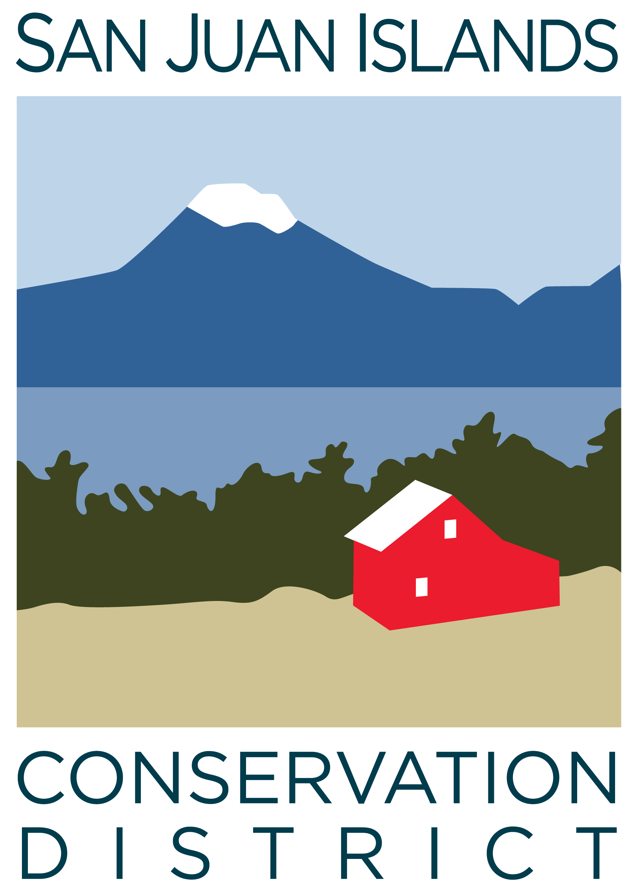
San Juan Islands Conservation District
BOARD OF SUPERVISORS
REGULAR MEETING MINUTES

Date: | July 2, 2025
Time: | 3:30 pm – 4:30 pm
Place: | 915 Spring St. Friday Harbor, WA 98250  And online via Zoom
Attending Supervisors: | David Bill, Lynn Bahrych, Vicki Heater, Claire Crawbuck, Roger Bairstow
Staff: | Paul Andersson, Julie Curtis
Partners: | Jean Fike, Washington State Conservation Commission

 | Welcome and Introductions
1 | Agenda Approval
 | The agenda was approved by consensus with no modifications
2 | Public Comment
3 | New Business
Resolution 2025-004 - Lynn made a motion to approve SJICD Resolution 2025-004 – Proposal to San Juan County for Updating the SJICD System of Rates and Charges – to forward to San Juan County for review, public hearing, and approval. The motion was seconded by Roger. The motion passed. Details of the discussion included:
- The resolution will set a new per-parcel annual rate at $25, up from $5 where it has stood since 2020 and would generate an additional $350,000 annually for SJICD operations ($440,000 total) from local property taxpayers.
- The price per acre was set at $.10 for all land use types except for Designated Forest Land which is capped at $3/parcel and $.01/acre.
- Exemptions for qualifying low income senior citizens and parcels under $500 value were retained from the existing system of Rates and Charges.
- The county should continue to retain 1% of revenues for processing fees.
- The timeline of the new system should be 10 years.
- A process for county residents to request an exemption will also be put into place if the proposal is approved by San Juan county.
- Some board hesitation to propose the full $25 per parcel given the state of taxation in the country.
- Points made about the vulnerability of the District with very little consistent ‘backbone’ funding to rely on in emergencies or plan long-term sustainability and program effectiveness around.
- Lots of support from councilmembers and community given all the impressive work the CD is getting done countywide right now – important work that would not be possible otherwise.
Public Hearing Date and Time – Roger made a motion to establish a public hearing hosted by SJICD on Resolution 2025-004 on Friday July 25th at 10am. Claire seconded and the motion passed. Discussion included:
- Draft language of the Public Notice of Public Hearing to be printed in newspapers and posters posted at a minimum of five physical locations throughout the county.
- Communications and materials to provide for public viewing pertaining to Rates and Charges – web page review, important documents, FAQs, etc.
4 | Adjourn

