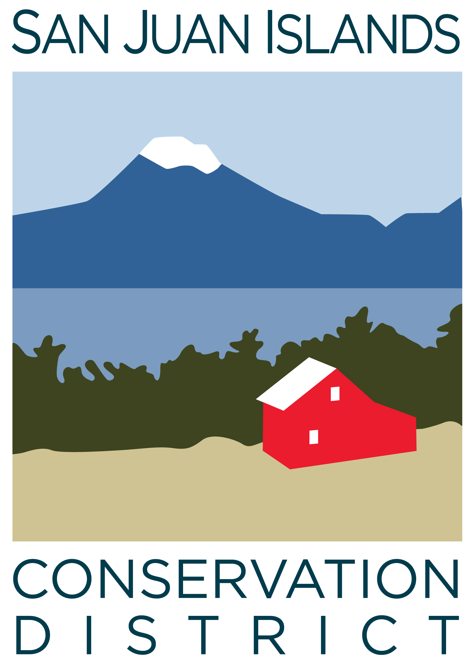
San Juan Islands Conservation District
BOARD OF SUPERVISORS
REGULAR MEETING MINUTES

Date: | August 22, 2025
Time: | 9:00am – 11:00am
Place: | 915 Spring St. Friday Harbor, WA 98250  And online via Zoom
Attending Supervisors: | David Bill, Lynn Bahrych, Claire Crawbuck, Roger Bairstow
Partners: | Jean Fike, WSCC Puget Sound Regional Manager; Alan Chapman, WACD NW Region Representative; Robin Buckingham NRCS Resource Conservationist
Staff: | Paul Andersson, Tony Fyrqvist, Mike Rosekrans
Public:

 | Welcome and Introductions
 | Lynn agreed to chair the meeting.
1 | Agenda Approval
The agenda was approved by consensus subject to the addition of items under Agenda item 9:
- WACD NW Area Meeting on Oct 15
- Puget Sound Leadership Council Meeting on Aug 20
- Senator Murray staff member visit to SJCID office on Aug 18
- Farm Tours
2 | Minutes Approval: July 25 Regular Meeting
 | Action Item: David made a motion to approve the July-25 Regular Meeting Minutes. The motion was seconded by Claire. The motion was approved.
3 | Public Comments
 | None.
4 | Partner Reports
Discussion:
NRCS, Robin Buckingham
- Winding down Fiscal Year Ending 9/30/25 with average volume.
- Inflation Reduction Act funding levels renewed for the next fiscal year under the One Big Beautiful Bill Act passed by US Congress.
- Robin continues to serve Skagit, Island and San Juan Counties.
- Discussed the possibility of a NRCS staffer at SJICD offices.
- EQIP applications will be available in a few weeks.
WSCC, Jean Fike:
- Commission is working on 2026 Decision Packages to be provided to state legislature.
- Commission is working on reappropriations of funds left over from previous biennium.
WACD, Alan Chapman:
- Area meeting is scheduled for mid Oct-25.
- Time to submit resolutions is approaching.
- Dues invoices have been sent out with an additional request for state program funding.
5 | Financial Report – June Financials
 | Action Item: The Financial Manager reviewed the 6/30/25 Financial Summary as presented. 7/31/25 numbers were not available due to the District working on upgrading the accounting system. Claire made a motion to approve the financial statements with the projected revenue increase as stated in the Financial Summary and was seconded by Roger. The motion passed.
 | Discussion: Discussed grants on the Grant Pipeline Report and FY26 budget outlook.
6 | Old Business
Discussion:
- 8/1/25 District held a public hearing on the proposal to increase the annual per parcel rate to $25.00 as allowed by Substitute House Bill 1488 as signed into law by the Governor on 5/13/25.
- 9/23/25 - The Executive Director will present the proposal for Rates and Charges to the County Council.
- 10/21/25 – County Council Public Hearing on updated Rates and Charges.
7 | New Business
Discussion on District hosting a WSCC Meeting in Mar 18-19, 2026:
- Lodging alternatives.
- Transportation, ferry challenges if bringing a vehicle.
- Last time hosted in 2017.
- Opportunity to network with partners and other districts.
8 | Staff and Program Reports
Report on YCC 2055 Summer Season:
- 38 crew members with 3,055 Stewardship and 1,000 Environmental Education hours at 47 locations, and 3 outreach events with 100 total attendees.
- 55.3% were returning crew members, 44.7% were new crew members.
- 30 days habitat restoration, 29 days noxious weed control, 17 days trail maintenance, 6 days of lighthouse repairs on Patos Island, 6 days of waste removal largely at San Juan County Fair and 5 days of community outreach.
- Total of 22 nonprofit, county, federal and state and private partners. 9 of the partners provide funding with 6 providing full funding.
- Total revenues amounted to $171,830 with the largest share provided by partner contracts but with the largest growth being from private donations. Total expenses amounted to $216,658 with the largest category being for Coordinator time.
9 | Recent & Upcoming Trainings/Webinars/Events
Discussion:
- Booth at SJC Fair generated interest particularly with landowners and members of the public concerned about wildfire preparedness.
- Placing a pin on the map specifying property location was popular.
- Location next to SJC Noxious Weeds was favorable.
10 | Idea Pot
Discussion:
- Benefits of septic education and outreach for homeowners.
- No-till drill signup calendar.
- Review of projects funded through the District.
- Usage of pond and rainwater catchment for irrigation. Construction of ponds.
- Irrigation needs by agriculture.
- NRCS funding for irrigation tends to go to large systems.
- Measure agricultural water use in the county and study water use resources.
11 | Adjournment 11:00 am
Next Meeting: |  | Regular Meeting - Friday, September 26, 2025, from 9:00am to 11:00am.

