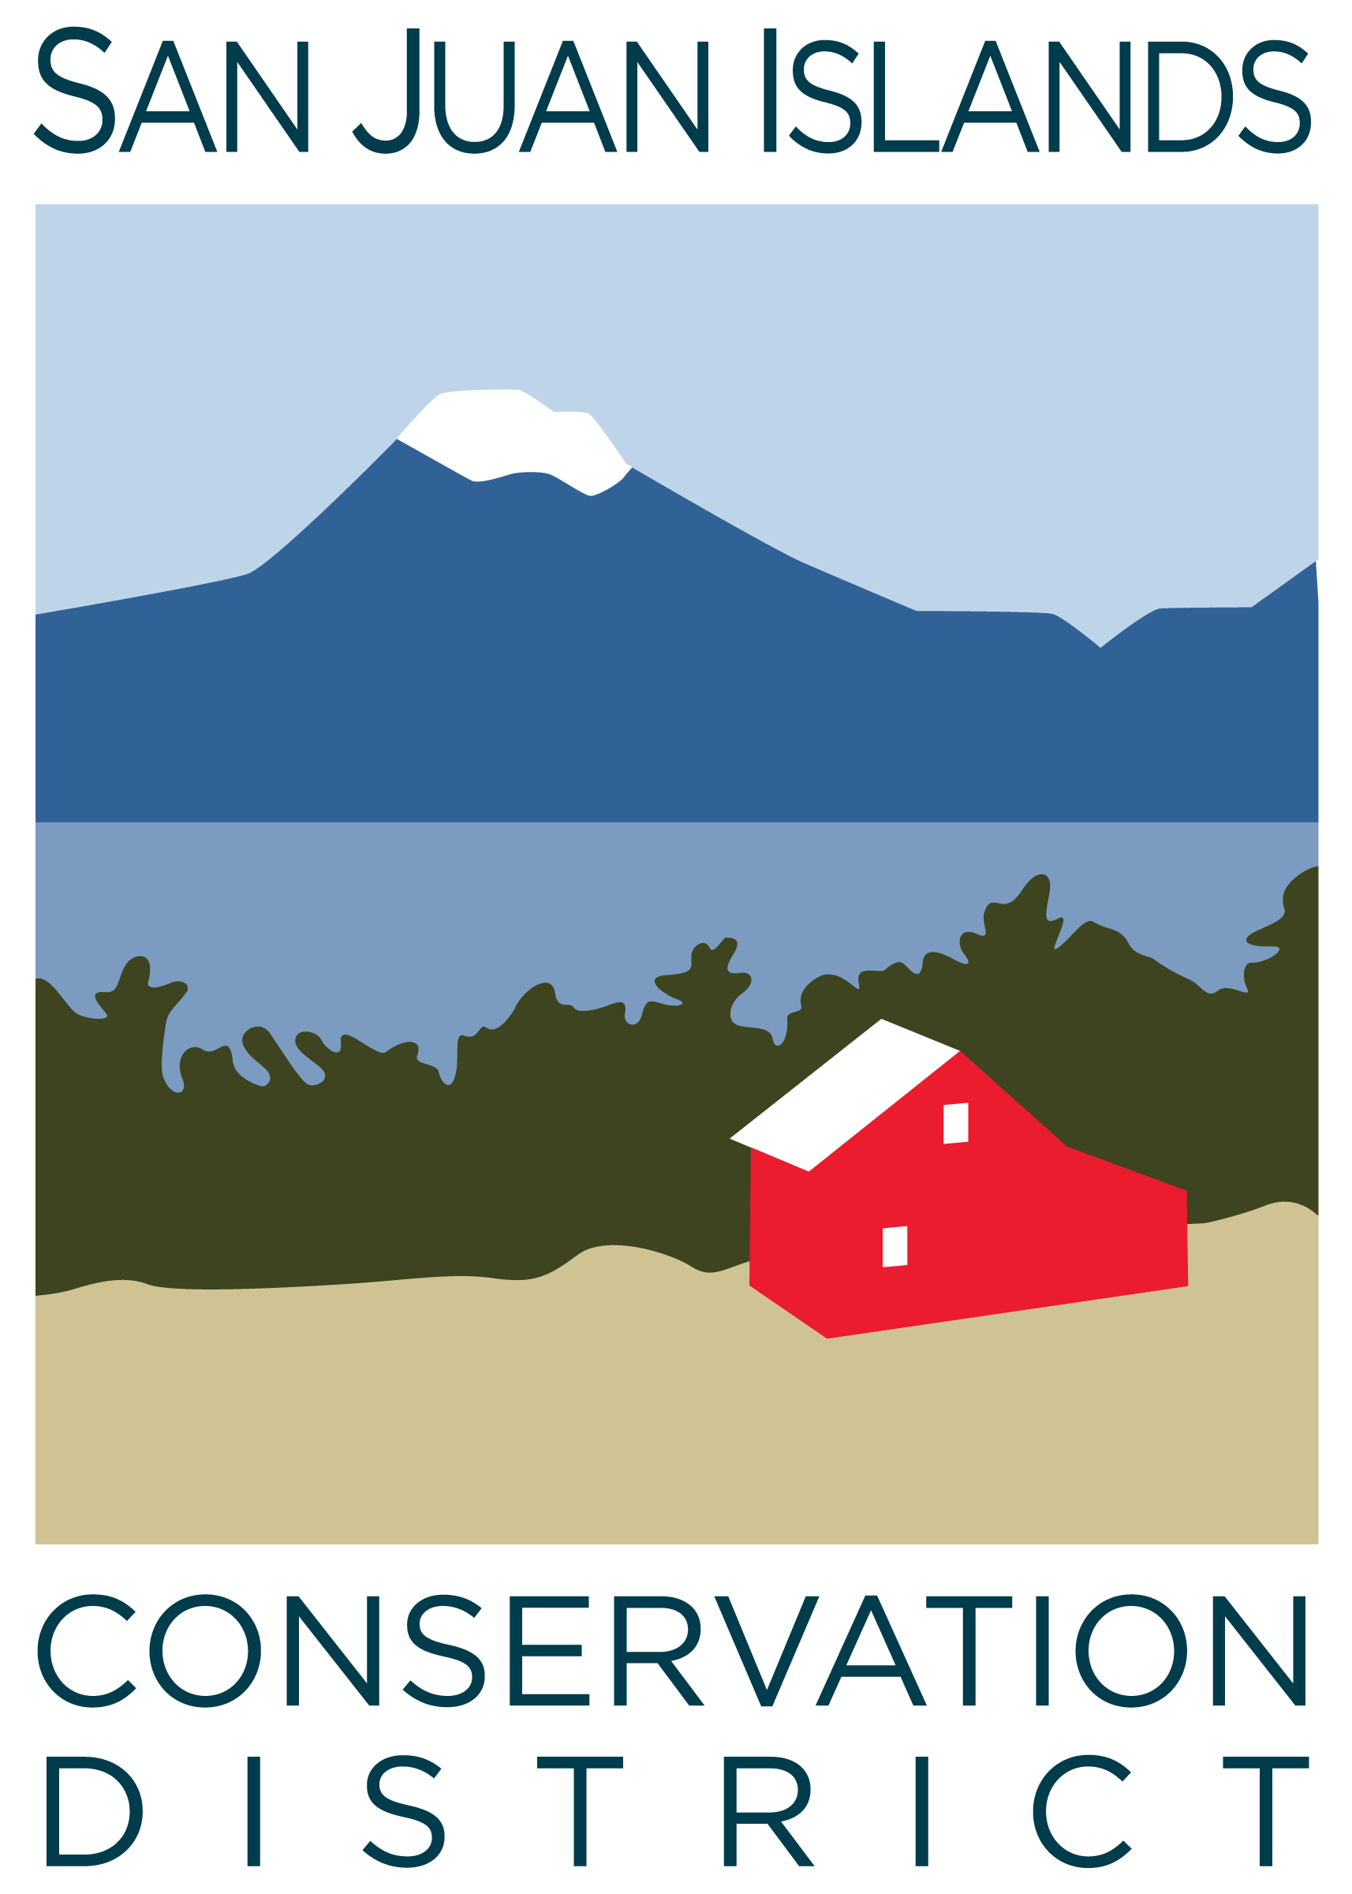
San Juan Islands Conservation District
BOARD OF SUPERVISORS
REGULAR MEETING MINUTES

Date: | September 26, 2025
Time: | 9:00am – 11:00am
Place: | 915 Spring St. Friday Harbor, WA 98250  And online via Zoom
Attending Supervisors: | David Bill, Lynn Bahrych, Claire Crawbuck, Roger Bairstow
Partners: | Jean Fike, WSCC Puget Sound Regional Manager
Staff: | Paul Andersson, Tony Fyrqvist
Public:

 | Welcome and Introductions
1 | Agenda Approval
The agenda was approved by consensus subject to the addition of the following under Agenda item 7
- WACD Area Meetings and Resolutions
2 | Minutes Approval: August 25 Regular Meeting
 | Action Item: Lynn made a motion to approve the August-25 Regular Meeting Minutes. The motion was seconded by Roger. The motion was approved.
3 | Public Comments
 | None.
4 | Partner Reports
Discussion:
WSCC, Jean Fike:
- Expressed appreciation for Dean Longrie for his service as a Commissioner, and to look for the opportunity to vote for the next West Side Representative for the Commission.
- Discussed challenges surrounding the biennial transition and process improvement work under way.
- The Ombuds group is meeting on Tuesday 9/30/25 to discuss potential changes to the Grants and Contracts Procedures Manual.
- At the end of each biennium leftover capital funds are reappropriated back to the districts through an ongoing process, while leftover operating funds are not reappropriated.
5 | Financial Report – July – Aug-25 Financials
 | Action Item: The Financial Manager reviewed the 8/31/25 Financial Summary as presented. Income Statements and Balance Sheets for 7/31/25 and 8/31/25 were not available due to the District working on the upgrade to the accounting system. However, the bank account balances, receivable and invoicing information were incorporated into the Financial Summary. Due to the collection of all Jun-25 biennium end invoicing the operating account balance is at record levels. After cash flow stabilization within the new biennium, and after paying for the painting of the building, the District will evaluate the goal of transferring additional $100,000 into the reserve account to maintain approximately 3 months of payroll coverage. Additional funds in the reserve account will also increase the interest earnings for the District. Lynn made a motion to approve the Grant Balance Tracking, Credit Card Details and Payroll reports and was seconded by Claire. The motion passed.
 | Discussion: Executive Director discussed the Grant Pipeline Report, noting that the $1,100,000 Community Wildfire Defense Grant was not approved. However, Orcas Island Community Foundation approved a grant for the District for $3,000 under the LEAD program.
6 | Old Business
Discussion:
- San Juan County public hearing on rates and charges is scheduled for 10/21/25 at 9:15 am.
- Discussed County budget and potential new funding requirements by other public agencies.
- 9/23/25 - The Executive Director presented the proposal for Rates and Charges to the County Council.
- Discussion on hosting WSCC Commissioners meeting in March on San Juan Island, focused on lodging options.
7 | New Business
 | Action Item: Lynn made a motion to approve the YCC Budget. She was seconded by Claire. The motion was approved.
Discussion: The following Board Members terms are subject to renewal in 2026:
- Lynn Bahrych – Appointed
- Roger Bairstow – Elected
The election process will start later in the year, and a brief discussion ensued regarding the benefits of co-chairing.
Discussion:
The Executive Director Performance reviews will be coordinated by Roger using a format similar to last year with surveys sent to staff members and Board communication with program managers.
8 | Staff and Program Reports
 | Discussion: Review of staff and program reports.
9 | Recent & Upcoming Trainings/Webinars/Events
Discussion:
- The Farms Tours booth at Krystal Acres Alpaca Farm on San Juan Island Sep-26-38 will be staffed by District Employees. Farm Tours will be an exciting event on San Juan, Orcas and Lopez.
10 | Idea Pot
Discussion:
- Old growth trees and introduction of forests on long standing pasture lands.
- Inspiration by the Gruffalo English childrens books for education in conservation.
- Encourage local sourcing of firewood to build resiliency/industry on the islands. Firewood from California has introduced invasive species of insects to the islands.
- Natural resource based businesses on the islands are experiencing challenges to profitability, which may be eased by state policy changes allowing wine and beer sales at farm stands.
- In Scotland farmers have developed creative ways to distill whey and livestock waste products to spirits.
11 | Adjournment 11:00 am
Next Meeting: |  | Regular Meeting - Friday, October 24, 2025, from 9:00am to 11:00am.

