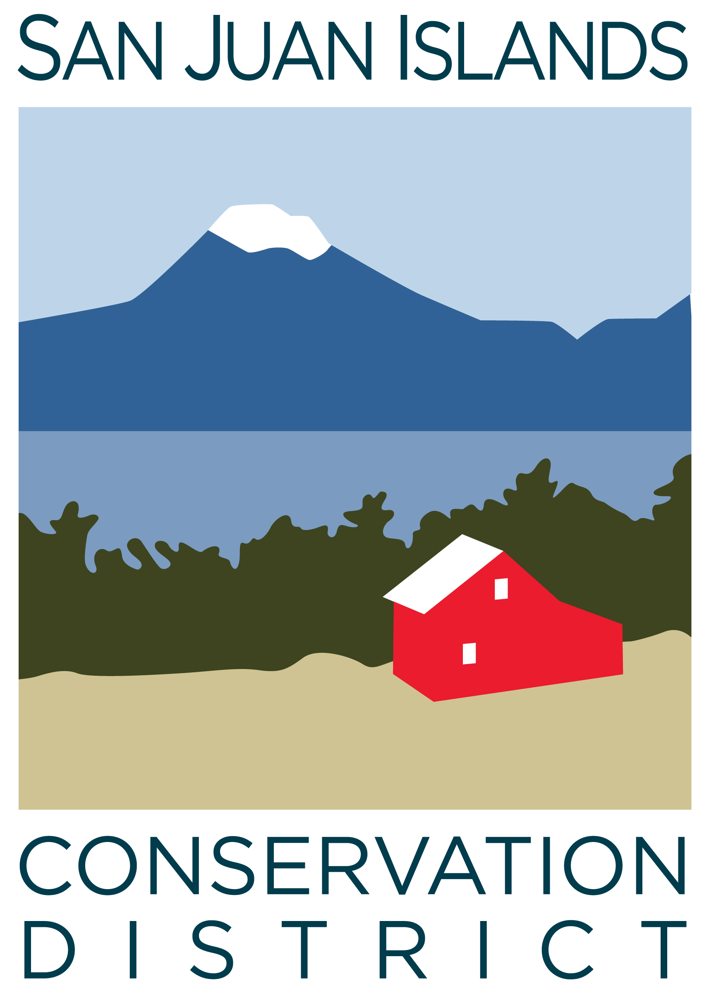
San Juan Islands Conservation District
BOARD OF SUPERVISORS
special MEETING MINUTES – board retreat

Date: | April 12, 2024
Time: | 12 – 3pm
Place: | 273 Front St, Friday Harbor, WA 98250
Attending Supervisors: | Carson Sprenger, David Bill, Vicki Heater, Lynn Bahrych, Claire Crawbuck
Attending Associates: | Jim Skoog
Absent:
Partners:
Staff: | Paul Andersson
Public:

1 | Agenda Approval
 | Action Item: The agenda was approved by consensus.
2 | Strategic Planning
 | Discussion: The FY2025 Annual Work Plan was discussed in its entirety. Minor additions were discussed and agreed upon, with the overall understanding that the Work Plan was thoroughly updated last year and will be in-process for several years.
3 | Discussion – Conservation Campus “Concept to Reality”
 | Discussion: The acquisition of the 915 Spring St building was discussed, including closing dates, sublease details, interior design aesthetic, and moving logistics.
 | Closing Thoughts and Adjournment

