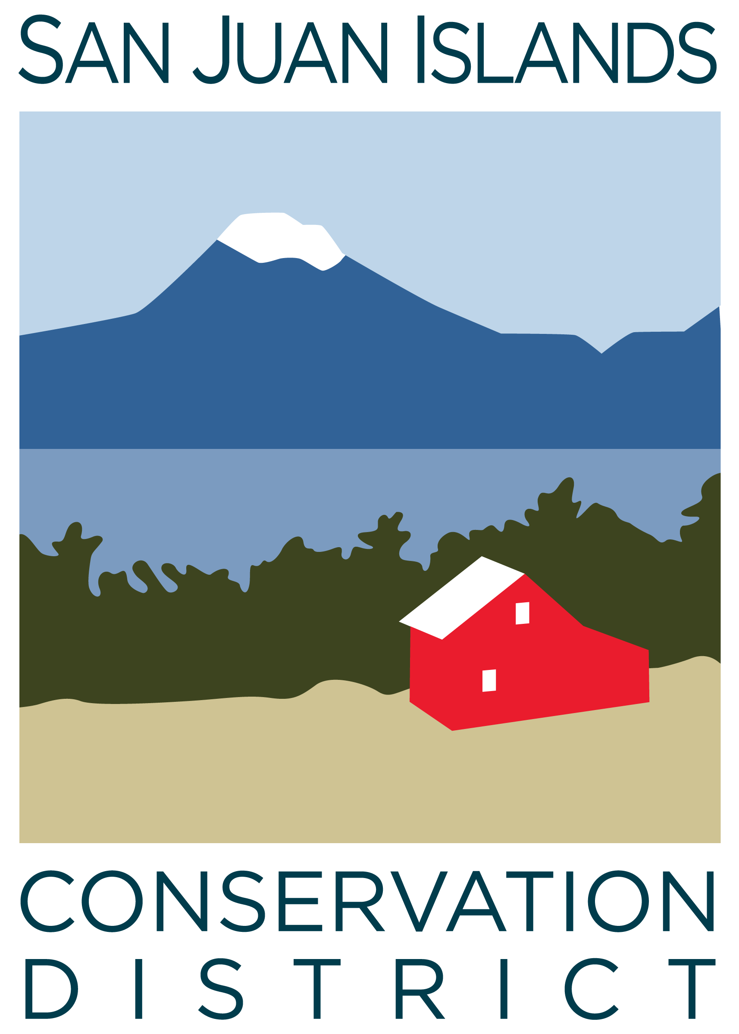
San Juan Islands Conservation District
BOARD OF SUPERVISORS
REGULAR MEETING MINUTES

Date: | June 26, 2026
Time: | 9:00am
Place: | 915 Spring St. Friday Harbor, WA 98250  And online via Zoom
Attending Supervisors: | David Bill, Lynn Bahrych, Vicki Heater, Claire Crawbuck, Andrew Jones
Partners: | Alan Chapman; WACD NW Region Representative
Staff: | Paul Andersson, Tony Fyrqvist, Heidi White, Mitch McCloskey, Sage Enright, Vicky Lewin
Public: | None

 | Welcome and Introductions: David called the meeting to order at 9:01am.
1 | Agenda Approval
 | The Agenda was approved by consensus.
2 | Minutes Approval: May 22, 2026 Regular Meeting Minutes Approval
 | Action: Lynn made a motion to approve the May 22, 2026 Regular Meeting Minutes. The motion was seconded by Andrew and approved unanimously.
3 | Public Comments
 | None.
4 | Partner Reports
WACD, Alan Chapman discussed:
- WACD discussed their budget at recent board meeting; Plant Materials Center was in the red for the first time in 20 years.
- WACD has cash reserves set aside to cover shortfalls.
- District dues have been the same since 2015 despite increased inflation. Prompt payment is appreciated
- $240,000 was transferred from investments to budget, more than was needed in past years
- Ways and Means is working on the resolution process; which may require earlier submission of resolutions to be better prepared for the legislative process.
- A work group will be set up with interested CD’s to prepare responses to the proposed election changes
- In Clallam County, a court case was filed alleging that CD rates & charges are illegal. The case was dismissed but is currently being appealed. WACD is monitoring the case. Paul noted that he is tracking this case and will keep the board informed.
5 | Financial Report – July 2025 – May 2026 Financials
Financial Manager Tony Fyrqvist reviewed the finance report with the board:
- Account balances remain stable month-to-month, but complete financial statements are not available from the new system yet.
- Financial Report numbers are currently being determined by manual record keeping, with the goal to move to Financial Edge to automate. The process is very time consuming.
- The 2024 single-year audit was a good learning experience. The district had a finding due to incorrect BARS reporting related to the federal loan for the building.
- Paul reported: Vicky Lewin is still working on the conversion to Financial Edge. The finance team had its first few meetings with Blackbaud Advisory+ consulting service. The district has retained them for the next 2 years.
- David thanked Vicki and Lynn for attending the Audit exit conference with the SAO and expressed appreciation that the district is seeking extra help by retaining Blackbaud.
- Tony noted that the cost of the audit does not reflect the internal cost of staff time. It was an expensive process. The district could consider paying down the building loan balance to fall below the threshold for the single-year federal audit for 2027. The district was already about the threshold for 2025 so will have another federal audit in six months.
- Paul said he will bring a proposal to the board to use reserves to pay down the loan balance. Staff will analyze available funds and make a proposal.

Action:
Vicki noted that the board can approve the financials presented but they are still missing key pieces. Vicki made a motion to approve the May 2026 Payroll and Expense Report. Lynn seconded the motion and it was approved unanimously.

- Paul reviewed the Grant Contract Pipeline Report and discussed current and new grants. The district recently entered into a new multi-year contract with OPALCO to establish a county-wide vegetation management plan for OPALCO powerline rights-of-way that have been cleared.

6 | Old Business
 | None.
7 | New Business
July Regular Meeting Schedule Conflict Discussion
Both Paul and Tony will be on vacation during the regularly scheduled July 24 meeting.
Action: After discussion, there was consensus to cancel the July board meeting. The board will reconvene at the regularly scheduled August 28th board meeting.
Lynn suggested a subcommittee meeting during July to discuss paying down the building loan. Staff will work on a cost/benefit analysis. Tony noted that the state could still audit the district annually for other reasons, even if the loan balance is paid down below the federal audit threshold.
Engineering Cluster Interlocal Agreement, 2026-2026
Action: Lynn made a motion to approve the Interdistrict Agreement for Providing Professional Engineering Services. Claire seconded the motion.
Discussion: Lynn said she reviewed the agreement and noted it was a great opportunity for the district to access engineering services when needed.
Action: The motion was approved unanimously.

Policy Subcommittee discussion – Governance Policy and Gift Receiving Policies
The board reviewed the draft changes to the Governance Policy.
There was discussion regarding at what level board approval is needed for district purchases and contracts and grants. Paul will bring a revised draft to the August board meeting.
Gift Receiving Policy: Paul drafted a gift receiving policy utilizing examples from other organizations. The policy was prompted after a resident expressed interest in donating a house and land to the district. Lynn asked board to review the draft for discussion at the August meeting.
County Funding Subcommittee Discussion
Andrew, David, and Paul met to discuss any CD response to San Juan County budget shortfalls. They discussed bringing SJICD and WSU Extension closer by providing grant-writing assistance, offering office space for staff, and helping increase native plant sale offerings, among other things.
Discussion: The board was very supportive of offering support to WSU Extension, beginning with asking them what they need.

8 | Staff and Program Reports
 | Sage Enright and Mitch McCloskey joined the meeting and gave a presentation on their Seed-based Eelgrass Restoration Project and lessons learned. Today is Mitch’s last day as a full time CD employee – thank you Mitch!
9 | Recent & Upcoming Trainings/Webinars/Events
- See agenda. Discussed past events.
- Paul said Julie Curtis will send out a sign-up sheet to board and staff to help at the CD’s County Fair booth.
10 | Idea Pot
 | - None.
11 | Adjourn Regular Meeting Lynn adjourned the meeting at 10:57 am

