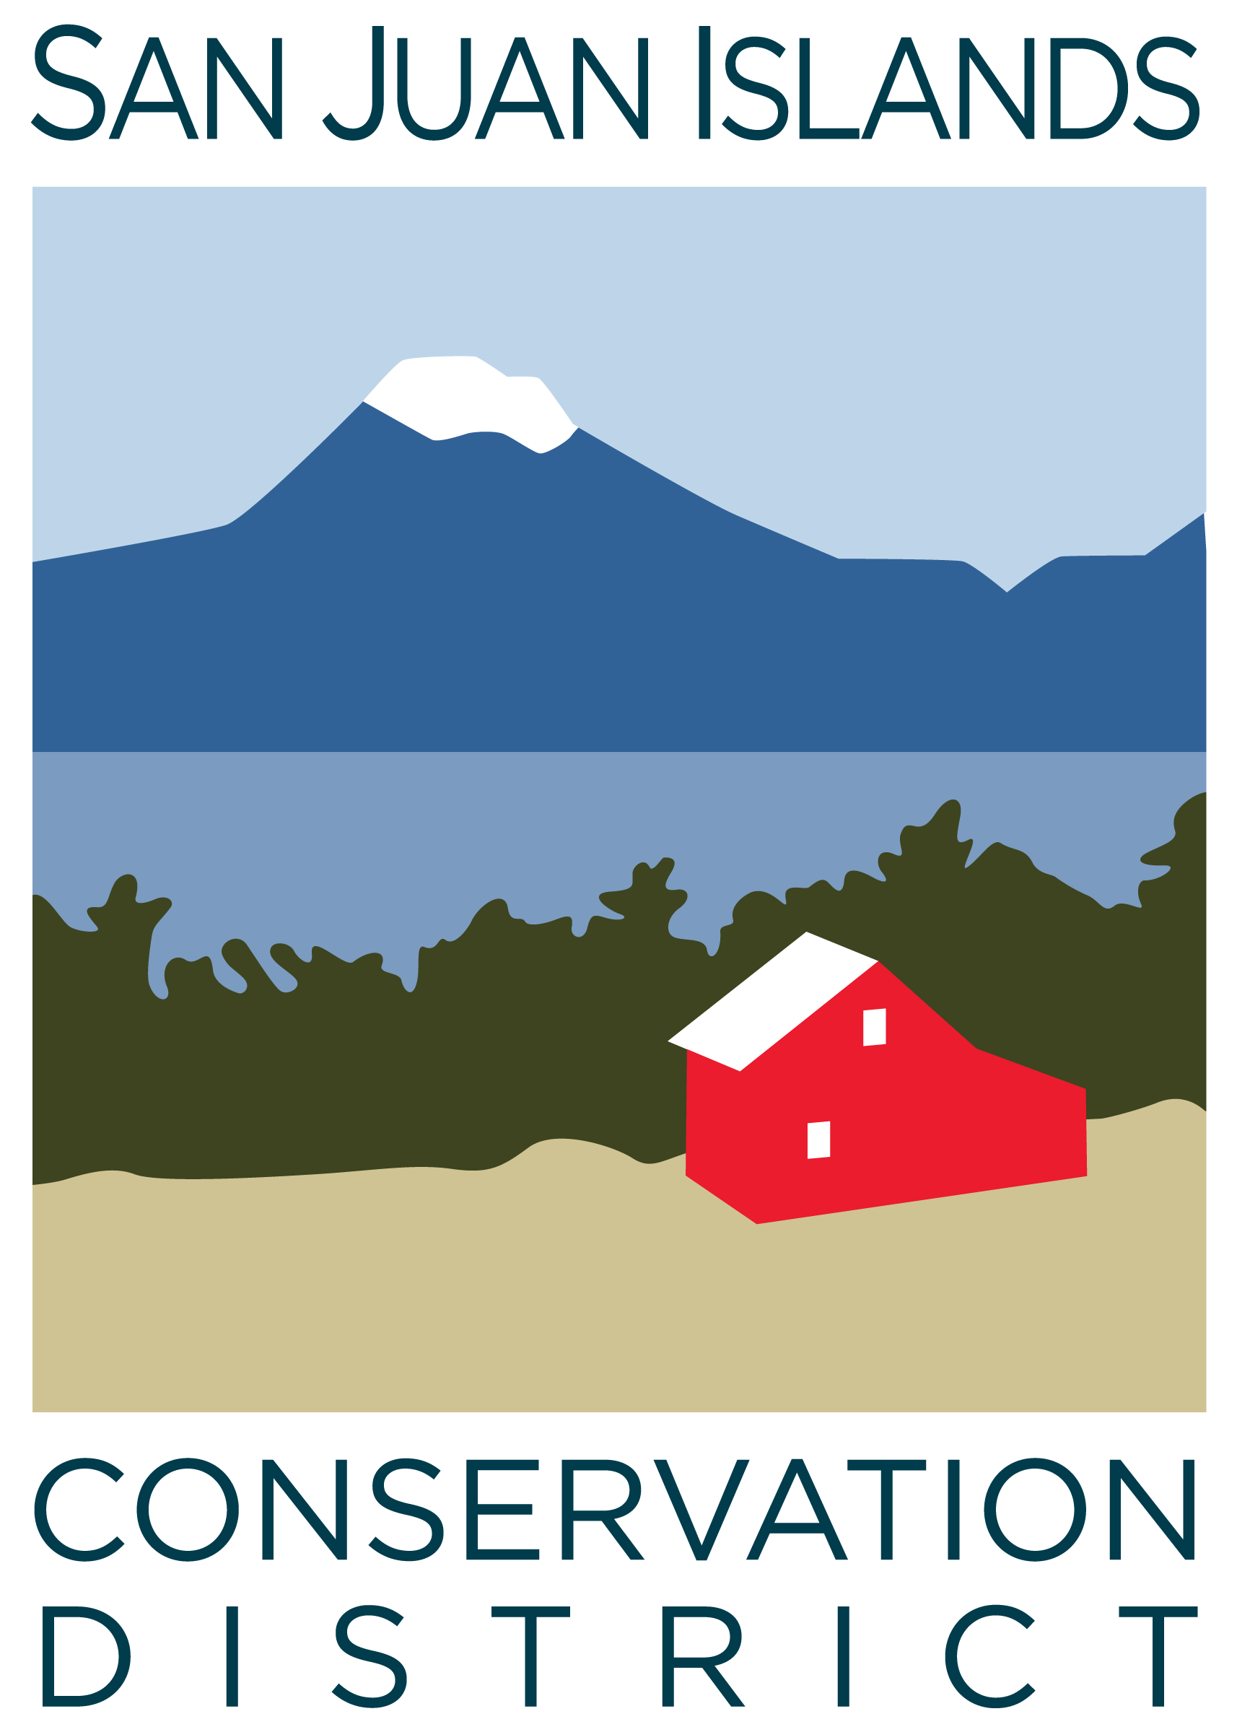
San Juan Islands Conservation District
BOARD OF SUPERVISORS
REGULAR MEETING MINUTES

Date: | May 23, 2025
Time: | 9:00pm – 11:00pm
Place: | 915 Spring St. Friday Harbor, WA 98250  And online via Zoom
Attending Supervisors: | David Bill, Lynn Bahrych, Vicki Heater, Claire Crawbuck
Partners: | Alan Chapman, WACD NW Region Representative; Robin Buckingham NRCS Resource Conservationist
Staff: | Paul Andersson, Tony Fyrqvist
Public: | Andrew Munson

 | Welcome and Introductions
1 | Agenda Approval
 | Lynn called the meeting to order at 9:00 am and confirmed that quorum was present.
 | Action Item: David made a motion to approve the Agenda. Claire provided the second and the motion was approved.
2 | Minutes Approval: April ’25 Regular Meeting, May 2 Special Meeting and May 12 Special Meeting
 | Action Item: David made a motion to approve the April-25 Regular Meeting Minutes simultaneously with the May 2nd and May 12th Special Meeting Minutes. The motion was seconded by Claire. The motion was approved.
3 | Public Comments
 | None.
4 | Partner Reports
Discussion:
WACD, Alan Chapman
WACD Board Meeting of 5/19/25 discussion topics included:
- SW Region districts expressed concerns about forest health funding.
- Emphasis was placed on unity between Districts, Commission and WACD.
- Dues packages to districts will include a feedback requests about how WACD can provide help to districts with specific requests and expand activities important to Districts.
- Allocation of $25 million in riparian funding to Conservation Commission and $20 million to RCO, there is some CD opposition for using funding for land acquisitions.
- Ways and Means Committee is in charge of implementing District resolutions.
- Plant Materials Center (PMC) expenses were up by $100,000 but income was up by more than $100,000.
- Manager Jim Brown will be leaving PMC.
- Heather Wendt has been appointed as the Deputy Director of WACD while Tom is on leave.
- Legislative Review meeting will be held on June 12th after WADE.
- Board Meeting on June 16th will cover long-term strategic planning.
NRCS, Robin Buckingham:
- Sarah Tanuvasa, District Conservationist, has returned from her year-long military leave.
- Conservation Stewardship Program (CSP) application deadline was on May 2nd. All funds have been allocated.
- A National Standard has been established for Biochar work requiring burn plans and certifications for staff involved with controlled burns possibly necessitating usage of service providers. It was noted that SJICD has certified staff available, and continued access to Task Orders by SJICD was encouraged.
- There is some possibility that Inflation Reduction Act (IRA) funding may be released for CSP or for EQIP (Environmental Quality Incentives Program).
 | Action Item: Lynn made a motion to approve the SCC Master Contract No.26. It is a standard contract requiring signatures from Board Chair and Co-Chair. The motion was withdrawn as all Board Members have not had the opportunity to read it.
5 | Financial Report – April Financials
 | Action Item: The Financial Manager reviewed the Financial Summary as presented. Comments were made about the end of the biennium and the high level of grant balances resulting in record invoicing volume and equity levels. Lynn made a motion to approve the financial statements and was seconded by Vicki. The motion passed.
 | Discussion: Grant pipeline report with particular emphasis placed on appreciation of the $150,000 2-year grant from a private individual through The Community Foundation for Northeast Florida for District fundraising and development efforts.
6 | Old Business
 | Action Item: Vicki made a motion to approve the SJICD FY 26 Annual Plan and Budget, she was seconded by Lynn. The discussion covered the final budget numbers reflecting the approved State budget. Objective #6 under Administration and Operations was modified to read: “Ensure services are delivered to all residents fairly and without discrimination”. The motion passed.
7 | New Business
Discussion: Substitute House Bill 1488 regarding Rates & Charges to allow for maximum annual per parcel rate to not exceed $25.00 (up from $5.00 for counties with population of less that 480,000 persons) with maximum annual per acre rate not to exceed 10 cents has been passed by Legislature and signed by the Governor on May 13, 2025. In light of the multiple benefits to San Juan County from District work it was agreed that the County Council would be contacted about a possible increase in the local system of rates and charges which would become effective in 2026. Some of the benefits mentioned included:
- Currently $88,000 in Rates and Charges are leveraged to approximately $2.5 million in benefits to the County.
- The District performs substantial riparian, forest health, wildfire mitigation and other service work.
- The current wait lists include approximately 30 farm plans and 30 forest plans.
 | Discussion: It was agreed to retain District Cost Share Policy unchanged. All exceptions to the policy regarding landowner contribution will be approved by the Board on a case-by-case basis.
 | Discussion: Transportation logistics and food for the staff retreat.
8 | Staff and Program Reports
Discussion:
- Staff and program reports with emphasis on ICC work on the 2012 Community Wildfire Protection Plan (CWPP) projects on Waldron Island.
- Weather report, rain gauges, and precipitation being 3.1” below normal at weather station WA-SJ-8.
- Appreciation was expressed for the outreach and communications work by staff.
9 | Recent & Upcoming Trainings/Webinars/Events
Discussion:
- WADE conference, June 9-11 will be attended by Paul and Julie.
- VSP Technical Panel will stage their first visit and stay overnight on Orcas Island on 6/25 and will also visit San Juan island the following day.
10 | Idea Pot
Discussion:
- Placement of the No Till Drill on Lopez Island. On Lopez farmers are experienced with maintaining and sharing farm equipment.
- Staging an open House for beginning farmers.
- Availability of low cost land to potential farms.
- Overmarsh Farm Commons operated by San Juan Island Grange provides community garden patches, medium plots and collaborative small farms.
11 | Adjournment 10:50 am
Next Meeting: |  | Regular Meeting - Friday, June 27, 2025, from 9:00am to 11:00am.

